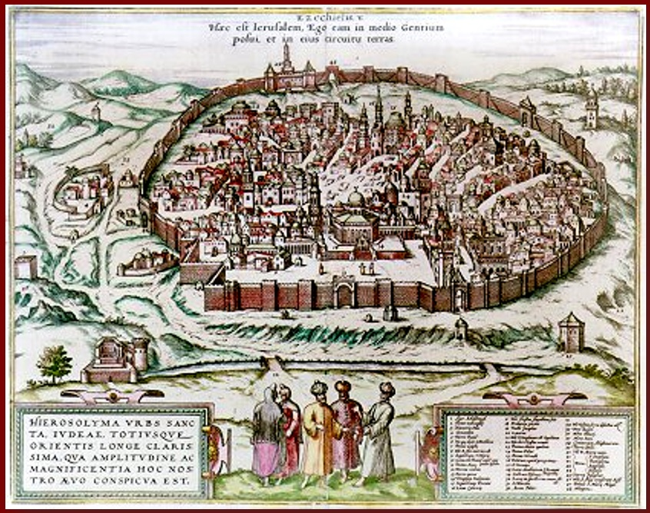
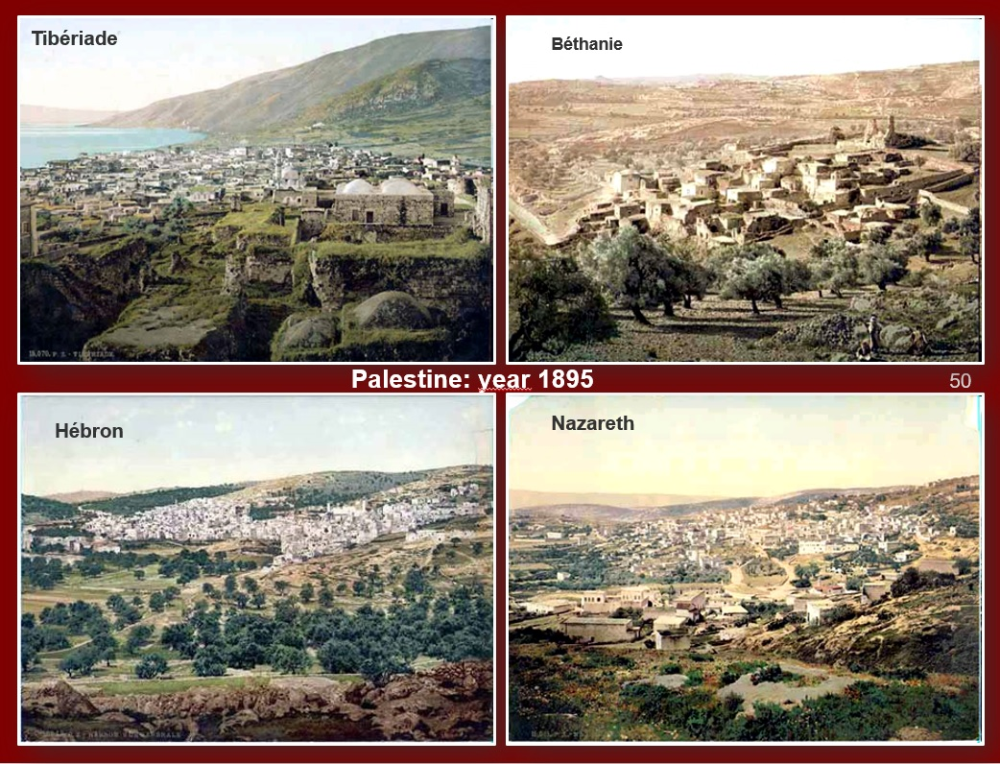
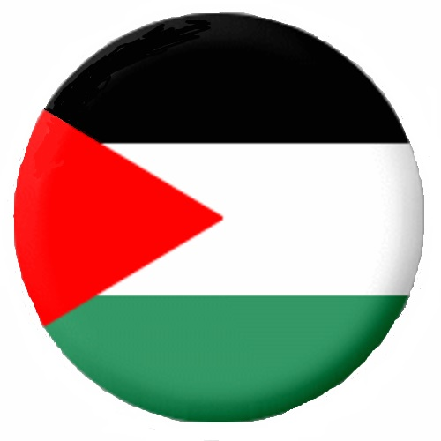
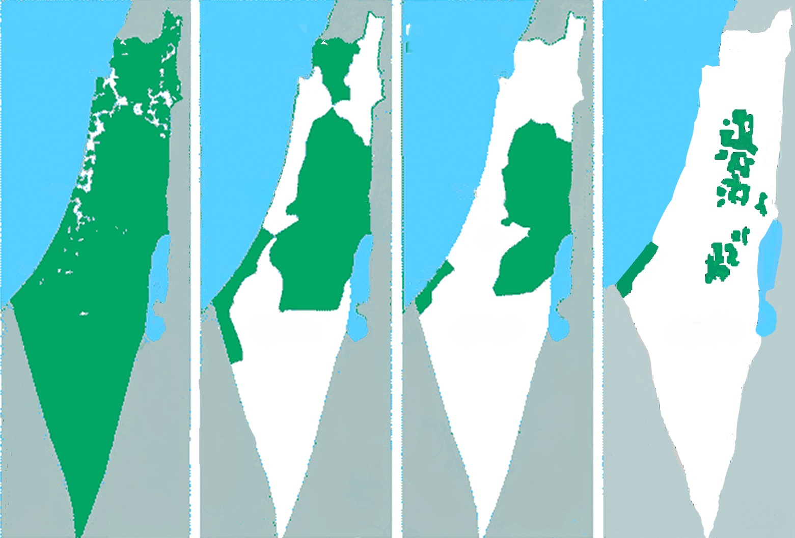
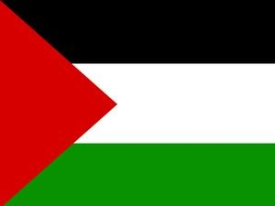
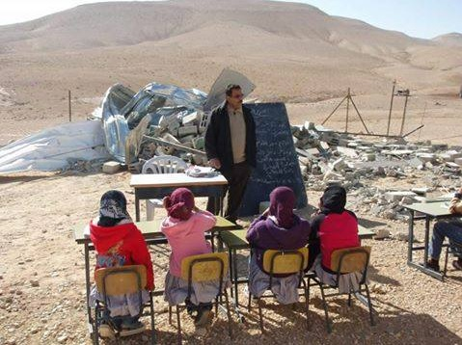
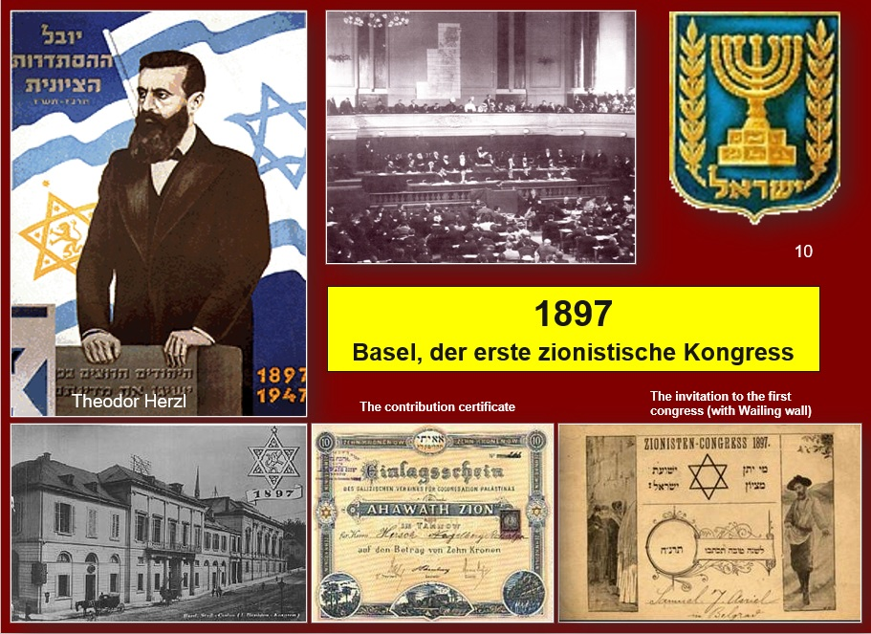
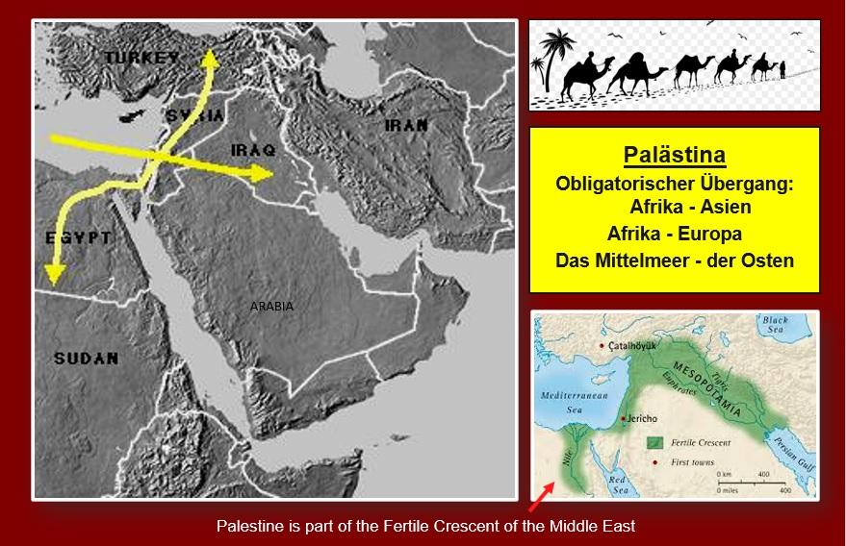
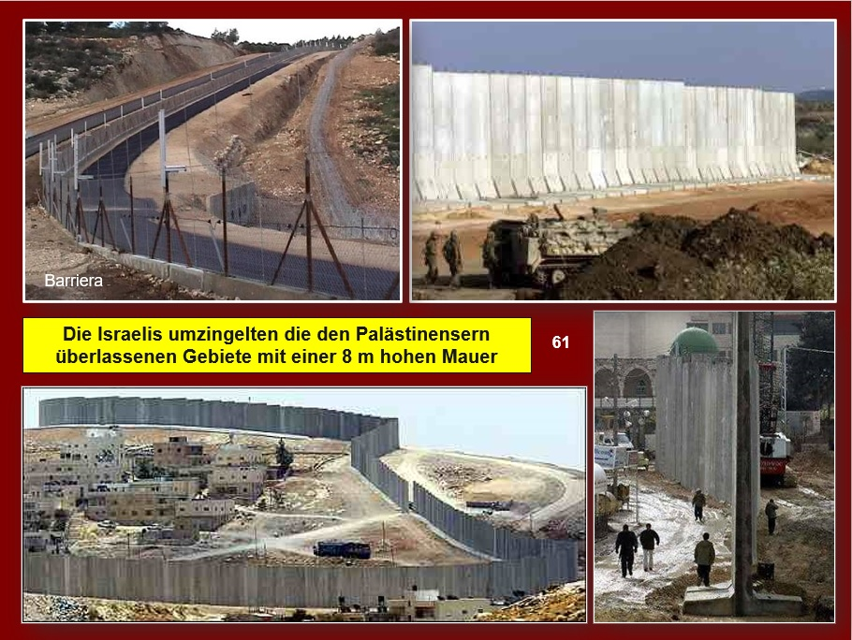
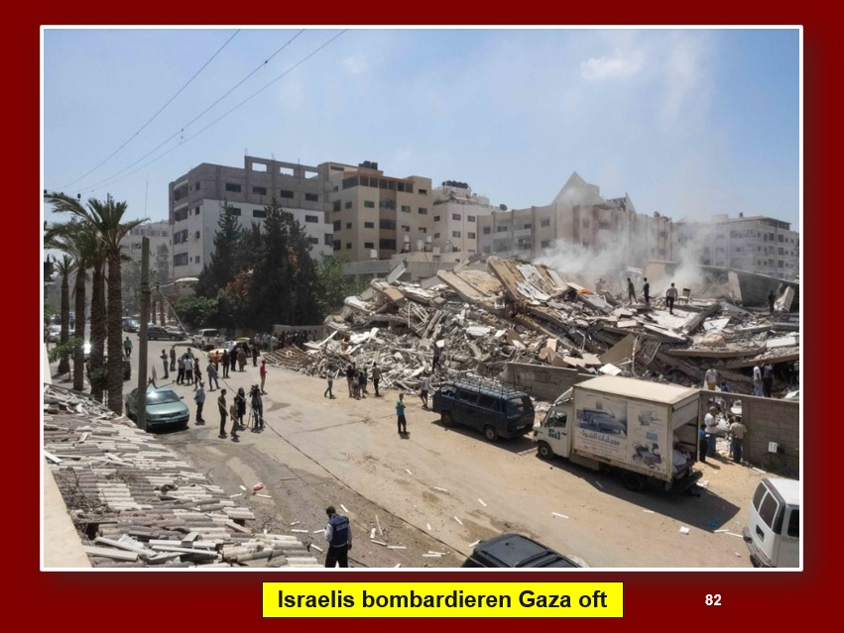
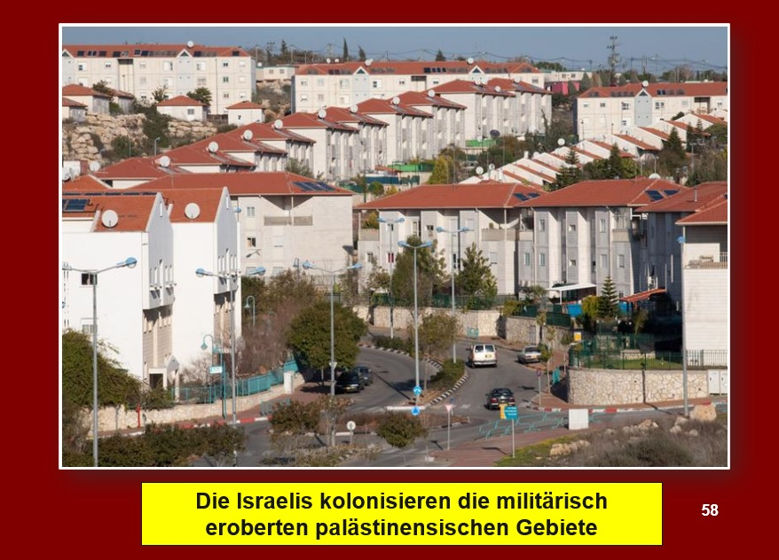
THE HISTORY OF PALESTINE IN IMAGES
English, Français, Deutsch, Italiano, Español

Download for free here: https://www.imparalavita.ch/eng/palestine_history.htm
simply
The Israelis destroy the Palestinian schools
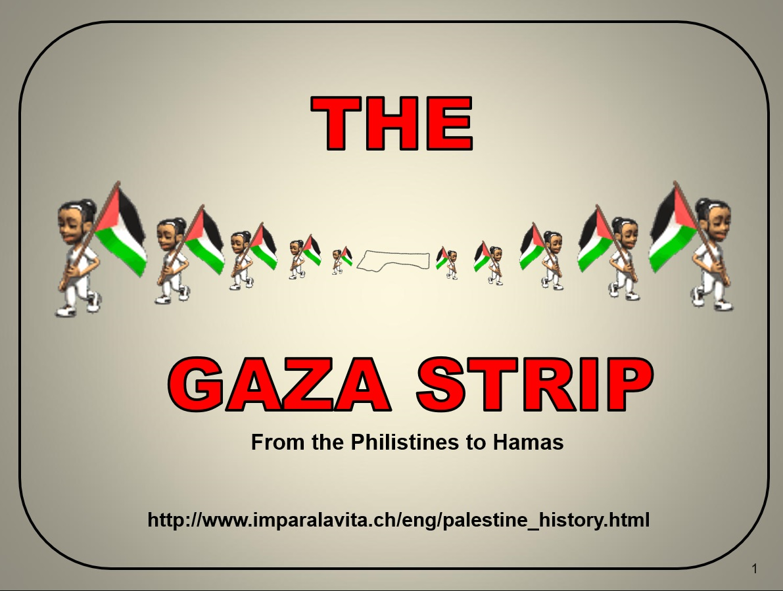
Palestine The only route between: Africa and Asia Africa and Europe the Mediterranean sea and the Orient
Palestine in the year 1900

Jerusalem in the year 1500
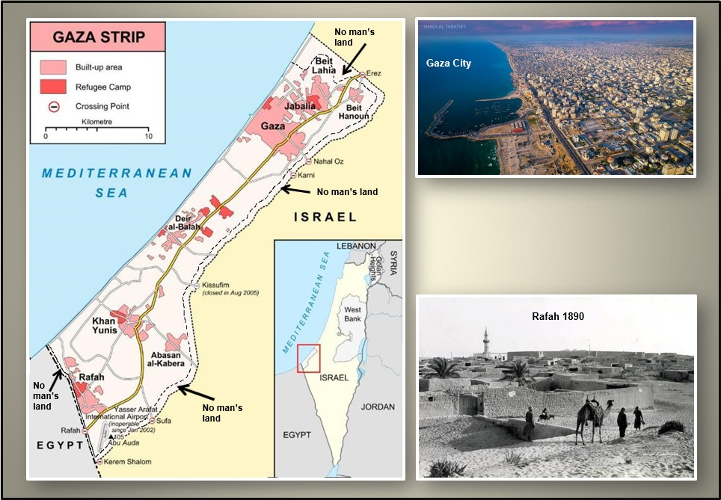
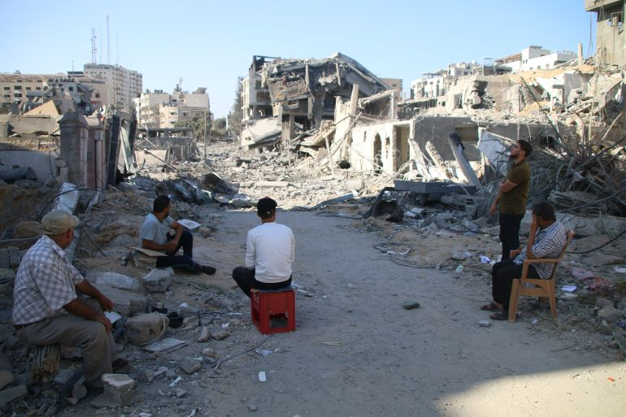
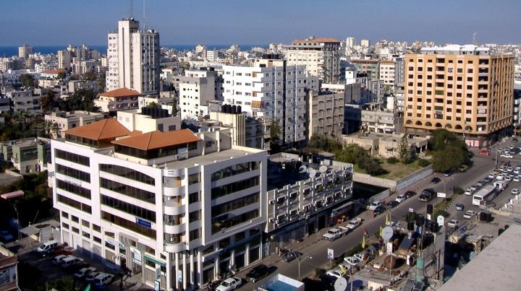
1897
Basel, the first Zionist congress
The Gaza Strip
The Gaza Strip yesterday and today

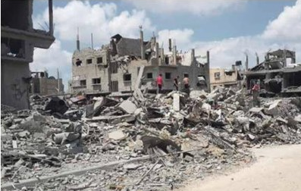

didactic
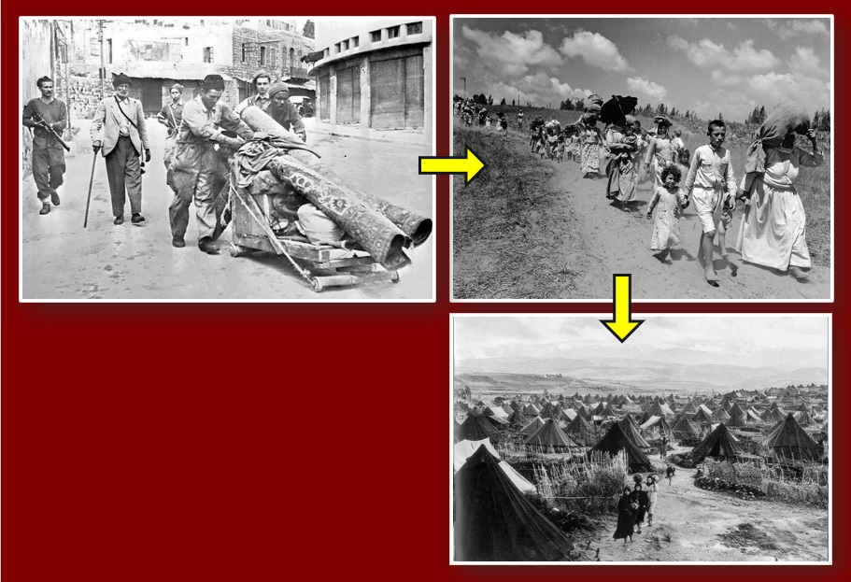
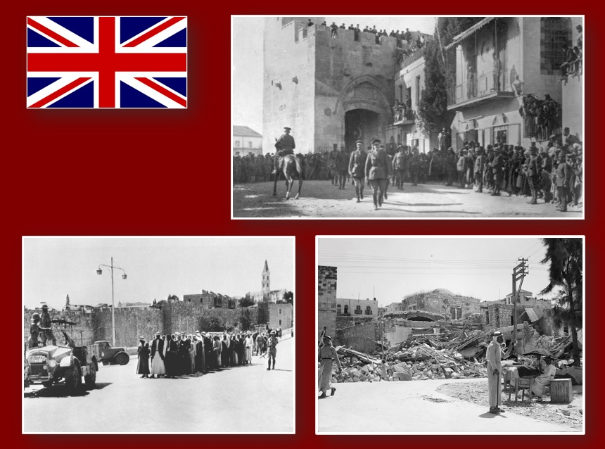
The Israelis often bomb the Gaza Strip
The Israelis surrounded the areas remaining to the Palestinians with an 8 m high wall.
1948 – 1949

Die Israelis vertrieben 850’000 Palästinenser
1917 - 1948 The British occupy Palestine
1937 - Mass arrest
1938 - House demolition
1948 - 1949 The Israelis drive away 850’000 Palestinians

Israelis occupy and colonize Palestinian land.
1938 - Collective arrest
1938 - House demolitions

