'Israel's Most Planned War': Historical Mossad File Details Lebanon Policy
How the IDF called the shots, meals at the Gemayels, and the remiss sale of weapons: The spy agency document revealing Israel’s work in Lebanon between the 1950s and the run-up to the First Lebanon War
Send in e-mailSend in e-mail

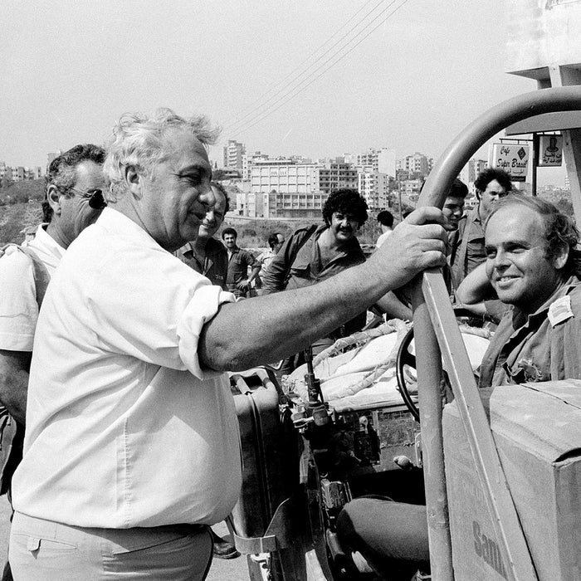
Then-Defense Minister Ariel Sharon (left) in Beirut, July 1982. Credit: Associated Press
Ofer Aderet
Sep 8, 2022 10:48 pm IDT
“It was Israel’s most planned war,” states an official Mossad document. “The preparations had already begun in mid-1981, and they gained momentum towards the end of that year. In January of 1982, Ariel Sharon met the Christian leadership – and said to Pierre Gemayel: ‘We are embarking on a full-scale war and that as a result of it, there ought to be change in Lebanon-Israel relations.’’
This account appears in a document submitted to the High Court of Justice by the Prime Minister’s Office – which is responsible for the activity of the Mossad spy agency – and released for publication this week. The state submitted “passages that have been approved for exposure,” unsigned and undated, in response to a court petition aiming to shed light on the connection between the Mossad and the Christian militias in Lebanon, which led to the massacre at the Sabra and Chatila refugee camps in Beirut in September of 1982. The petition was filed by attorney Eitay Mack.
In the document, the Israeli military is described as the body that effectively dictated policy on Lebanon, and not the elected government. “We have the Lebanese to do what we want them to do,” the document states. “That is the asset we have, now tell us what to do with it. Because the state isn’t all that organized in its decision-making, the ones who told us what to do with the asset wasn’t [Prime Minister Menachem] Begin, and the government, but rather the military.”
The document describes Israel’s military involvement in Lebanon’s affairs from the 1950s to the preparations for the First Lebanon War at the beginning of the 1980s. The connection was first created in 1958, at the request of the Lebanese president at the time, Camille Chamoun, who feared falling from power, in coordination with the Shah’s regime in Iran, which was sending arms to Lebanon by plane.
A Palestinian weeps at the Sabra refugee camp after the massacre there. Credit: Associated Press
In 1975, upon the outbreak of the civil war in Lebanon, Chamoun, a Maronite Christian and by then no longer president, again appealed to Israel for aid. Even then, according to the document, Israel did not consider the repercussions of selling the arms, some of which had originated in the Soviet Union and had been captured in the Yom Kippur War, and of the military training the Lebanese subsequently received. “There were no far-reaching diplomatic talks with the Christians, there was no profound discussion,” according to the document. The formula being used, it states, was the correct one: “We will help the Christians help themselves.” However, admits the author of the document, “we did not always see the interests involved correctly.”
- Lebanon War, 40 years on: The conflict that changed Israel
- 'I Showed Palestinians the Footage That Israel Looted. They Started to Cry'
- ‘Iran’s strategic goal in Lebanon has been achieved’
The connection that began with Chamoun broadened to other Maronite figures, among them the leader of the Al-Tanzim (literally “The Organization”) militia, Georges Adwan, and the head of the Guardians of the Cedars militia Étienne Saqr. On one occasion, according to the document, “[a]t the beginning of 1976 on a very rainy, stormy night, a boat that had apparently come down from Lebanon was in distress and was captured by the IDF. On the deck were three Lebanese. This group was coming to Israel with the intention of meeting with the Israeli leadership to ask for aid.”
The document tells two versions of the beginnings of the direct contact between the Israeli military and the Lebanese Christians. In one version, direct contact had already been established in 1975, while in the other version it began in 1976 with a visit by a delegation from the intelligence and operational branches of the Mossad to study “in an unmediated way what is happening in the war between those sects.” Among the representatives named is Benjamin Ben Eliezer, at the time a liaison officer to southern Lebanon and subsequently the head of Military Intelligence and eventually a Labor Party Knesset member and cabinet minister.
“We visited command posts of the Phalangists and the Chamounists, we had an additional meeting with Bashir Gemayel at his parents’ home in the village,” the document states. “As we were enjoying a meal, Amine Gemayel showed up in uniform from the front. He was very reserved with us, and barely agreed to shake our hands.” Subsequently, the Mossad took the lead in the responsibility for the meetings, but the document makes it clear that “everyone spoke with everyone.”
Bashir Gemayel (third from left) speaks with IDF Chief of Staff Rafael Eitan, 1982. Credit: IDF Spokesperson's Office
The method of transferring the arms is described in the document as “shipments that were loaded onto rafts of a sort that carried quantities of arms. We would arrive on a given night with two shipments, and in the third stage we refined it even more. We were suppliers, we sailed back and forth.” The arsenal that was transferred included 6,000 M16 rifles and 1,000 bullets for each rifle; 40 120 mm mortars with 300 shells for each of them, and 100 81 mm mortars with 200 shells for each.
In response to the petition, which was filed in 2020, the Mossad initially claimed it had difficulty locating the historical documents concerning its activity in Lebanon. Subsequently the documents were shown to Supreme Court President Esther Hayut, and she determined that some of the documents could harm Israel’s security if they were published, but asked the Mossad to re-examine whether it might be possible to uncover some of the material. The petition was dismissed last April, and this week the Mossad published the document.
According to Eitay Mack, the petitioner: “It’s a fascinating decision by the Mossad to reveal this document, even though it isn’t clear why.” The document suggests, he says, that “the massacre at Sabra and Chatila was one event in a chain of massacres, executions, abductions, disappearances, amputations and abuse of corpses carried out by the Christian militias. The clandestine affair must come to light and enable discussion and drawing of public conclusions that might prevent continued support by the Mossad and the State of Israel for security forces and militias around the world that commit atrocities. However, the Mossad still believes it has the right to continue to conceal information concerning this from the public.”

