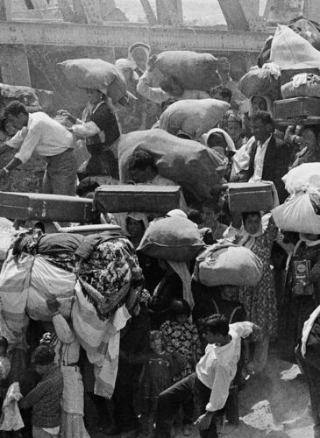
A Historical Reckoning: Oxford Study Challenges Israel’s Claims Concerning Palestinian Refugees

There needs to be a fundamental change in the way Palestinian refugees are seen, no longer as victims but as people with rights who are entitled to shape their own destiny. This assertion is made in a new study whose importance cannot be overstated.
According to international law, Palestinian refugees have a right to return to their homes and land and receive restitution and compensation for their suffering and personal and communal losses. Furthermore, the State of Israel, which is responsible for Palestine’s ethnic cleansing, must pay for the repatriation, the rehabilitation, and the rebuilding that the return will necessitate. A thorough understanding of why millions of Palestinians live as refugees and what international law says about their situation is critical, and a recently published study sheds unprecedented light on the Palestinian refugee issue.
The study states at the outset that, “At the time of publication, the unresolved exile of Palestinian refugees has entered its eighth decade.” Some refugees are third or even fourth generation, and they account for “the largest group of refugees globally.” Furthermore, it says, “theirs is the most protracted refugee situation in modern history.”
+++++++++++++
“Palestinian Refugees in International Law” (2nd Edition), by Francesca P. Albanese and Lex Takkenberg, was published in May 2020 by Oxford University Press. It is a comprehensive body of work on the Palestinian refugee issue, and its importance cannot be overstated. This study sets the record straight on what caused the refugee crisis, provides vital statistics and fills in crucial pieces of information regarding what international law says regarding Palestinian refugees.

Background
The original mass ethnic cleansing campaign of Palestinians by Zionist forces took place from 1947 to 1949. Although ethnic cleansing and internal displacement of Palestinians by Israel continued well into the 1950s, and in fact, continues to the present day, the ethnic cleansing campaign of 1947-1949 is what brought about the destruction of Palestine as it had been known for centuries. That campaign was responsible for the emergence of what the study calls “one of the largest and most protracted refugee crises of all times.” The majority of these refugees and their descendants, third and even fourth generation, are registered as ‘Palestine refugees’ with UNRWA and are commonly referred to as 1948 refugees.
The Palestinians who were exiled from the West Bank, East Jerusalem, and the Gaza Strip in 1967 are commonly referred to as “displaced persons” or “1967 refugees.” Their fate and status under international law are similar to that of the 1948 refugees. Still, different terminology is used regarding them because of the status of the land from which they were displaced – the Kingdom of Jordan, which at that point was an independent state. Each year, the United Nations General Assembly passes a separate annual resolution focusing specifically on them.
The Six-Day War: The Myth of an Israeli David Versus an Arab Goliath
Miko Peled reflects on the nefarious intent behind the Six-Day War, a war presented to the world as a heroic triumph of an outmatched Israel.
Refugee rights
Suffering a violent assault on their lives and property and suddenly deprived of protection by the government of Mandate Palestine of which they were citizens, Palestinians became stateless refugees. They were admitted into neighboring countries on what many expected would be a temporary basis. However, one could argue, as I do, that this expectation stemmed from a serious misunderstanding of the objectives and influence of the Zionist movement.
“For historical and political reasons Palestinian refugees enjoy a distinctive regime made up of specific norms and institutional arrangements different from those for other refugees.” This reality has affected the protection Palestinians deserve as refugees and often leaves them “excluded from the rights and standards of treatment afforded to other refugees.” In other words, Palestinian refugees are internationally recognized yet subject to a distinctive institutional regime compared to other refugees around the world. The distinction stems from special arrangements the UN had to make for them in 1948, seeing that the newly established Zionist state would not allow them to return.
One of the common mistakes people make regarding Palestinian refugees’ rights is the belief that securing rights in their host countries, including citizenship, will somehow undermine their claims towards Israel. This belief, according to this study, “must be put to rest.” In fact, the study goes on to state that for the rights of Palestinian refugees to be realized, the Palestinian community needs to make a paradigm shift, and international and regional diplomacy needs to provide a level of support “that has hitherto been largely lacking.”
Furthermore, the physical and political fragmentation that has befallen the Palestinian people and the diversity of legal frameworks and actors responsible for them have become features of their experience and misfortune. There needs to be a fundamental change in the way Palestinian refugees are seen, “not the victims of a failed political process, but as people with rights, entitled to shape their own destiny.”

Identity and numbers
“Today, out of over thirteen million Palestinians globally, about eight million are refugees.” 5.5 million are registered as ‘Palestine refugees’ with the United Nations Relief and Works Agency or (UNRWA) in Jordan, Lebanon, Syria, the Gaza Strip, and the West Bank.
The study estimates that some 1.5 million Palestinians are currently dispersed outside Arab countries, and their status and documentation make them statistically invisible and, therefore, difficult to track. As a result of their dispersal, Palestinian refugees’ identity is often hyphenated: Palestinian-Jordanian, Palestinian-Syrian, Palestinian-American, Palestinian-Iraqi, etc. It should be noted that for most Palestinians, long-term residence in host countries has not resulted in the protection afforded through citizenship.
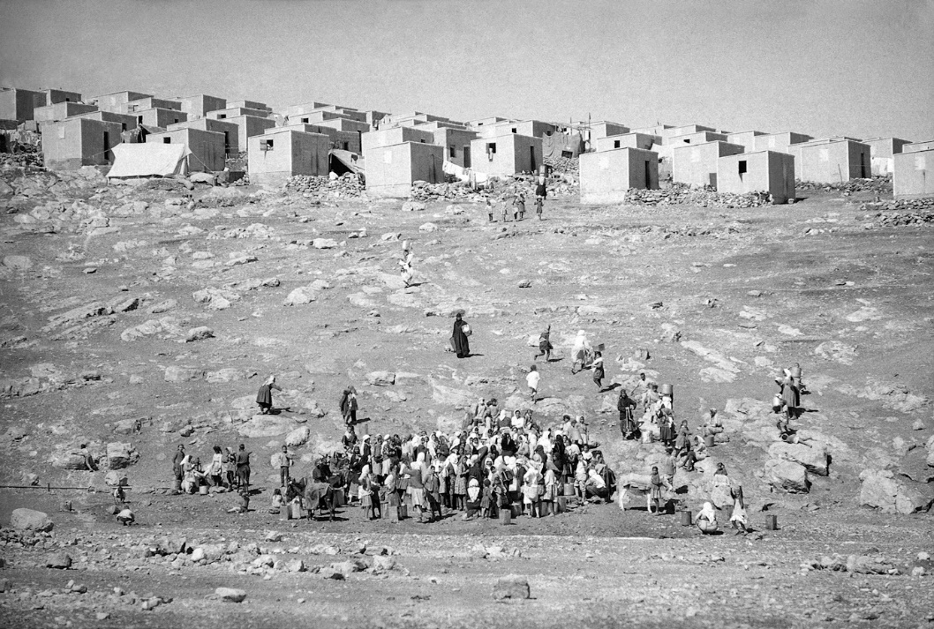
Palestinian refugees gather in the Bekaa refugee camp outside of Amman, Jordan, Oct. 28, 1970. Photo | AP
Another little known fact revealed repealed in this study is that since the late 1960s, more than 700,000 Palestinian refugees have been ejected from Arab countries, creating enormous challenges, including the need to seek asylum again in another country. What is worse is that the UN General Assembly did not confer a mandate to care for them. They are not included as a registered refugee population by UNRWA and do not receive comprehensive assistance from the agency.

A demographic issue
What has become known as the “demographic issue” is code for a Zionist obsession to establish a Jewish majority in Palestine – a territory that until then 1948 had a large Arab majority. This has been a pressing issue for Zionist leadership since the early years of the British Mandate. Still, despite British support for the Jewish national project and the waves of Jewish migration to Palestine since the late nineteenth century, at the end of 1947, Palestine’s Jewish population was only one-third of the total population of Palestine.
Britain facilitated Jewish migration to Palestine and turned hundreds of thousands of Jewish migrants from Europe into Palestine Mandate citizens. “The Citizenship Order of August 1, 1925, extended full citizenship rights to all Turkish (Ottoman) subjects habitually resident in Palestine.” This included the original 729,873 Ottoman citizens of Palestine, of whom the vast majority were Palestinian Arabs.
By 1946, the population of Palestine was estimated at 1,846,000. This included 1,203,000 Palestinian Arabs and 608,000 Jews. In the 30 years of British control over Palestine, the Jewish population grew over 30 percent compared to an average of 10 percent growth during the final 20 years of the Ottoman Empire, a time period already marked by increased Jewish immigration.
Reparations and the Palestinian Right of Return: Two Sides of the Same Bloody Coin
Both in Israel and the US, conversations about reparations and the Palestinian right of return are stifled by a yearning for the status quo.
The idea of forcing the Arab Palestinians out of Palestine through expulsion and transfer had become ingrained in the Zionist leadership mindset very early on. As early as the 1930s, the Jewish Agency had established a Population Transfer Committee which devised schemes to remove the Palestinian population “by securing land for them in neighboring states, or by having Britain remove them.” During 1948, several Transfer Committees were set up by the Jewish Agency, and later the Israeli government to “facilitate the exodus.”
By the time the armistice agreements were signed in 1949 between the new State of Israel and its Arab neighbors, only 15 percent of Palestine’s pre-1948 Arab population remained in the area that would become Israel.
Criminalizing return and confiscating property
The State of Israel declared independence on May 14, 1948. By June of that year, the Israeli government had decided to bar refugees from returning. In 1952, Israel passed the Nationality Law, which effectively excluded over two-thirds of Palestinian Arab citizens from retaining citizenship in British Mandate Palestine, a land that was still their own country.
In 1954, Israel passed the ‘The Prevention of Infiltration Law,’ which effectively criminalized the return of Palestinian refugees. Soldiers who saw “infiltrators,” a term used to describe any Palestinian attempting to return to their home or lands, were authorized to shoot them on sight. Those who were caught and not killed on the spot were imprisoned and expelled again.
This was not merely motivated by Zionist cruelty but also by greed.
The wealth that Palestinians left behind “was strategic to the emerging State of Israel.” Palestinians left behind huge tracts of farmland, tools, livestock, shops, factories, houses of worship, private homes, financial assets, and personal belongings. Produce from fields and orchards was also left behind, with large citrus fruit stores waiting to be exported for hard currency.
Moveable property was sold by Israeli authorities. The government even leased abandoned stone quarries and sold cactus fruit from abandoned fields. “Beyond this monetary gain, control of the refugees’ property allowed Israel and the Jewish Agency to cheaply settle hundreds of thousands of Jewish immigrants who began pouring into Israel after 1948.”
“The gap between such properties and their original owners/holders was further widened by the transfer, through ‘purchase agreements,’ to the Israeli Development Authority, and subsequently to the Jewish National Fund, for administration.” These Zionist institutions made it impossible for properties – both movable and immovable – of Palestinian refugees and internally displaced Palestinians to be restored to their rightful, legal owners.
In addition to severing the links between the land and its original owners, Israel transformed the territory to benefit its own economic growth. “By 1950, the Custodian had become the largest landlord in Israel.” It had acquired the legal authority to allocate Palestinian property to incoming Jewish immigrants.
In the 1950s, Absentee Property Laws consolidated the seizure of absentee properties and their transfer to the State of Israel for exclusive benefit of the Jewish population. Absentee property played a huge role in turning Israel into a viable state. It allowed Israel to take over farms and urban homes of Palestinians and populate them with Jewish newcomers from Europe and Arab countries. Jewish kibbutzim and agricultural settlements began the process of expropriating the land of both refugees and that of the Palestinians who remained in what became Israel. Palestinians who remained had no choice but to work for the same Israeli owners who had stolen their land.
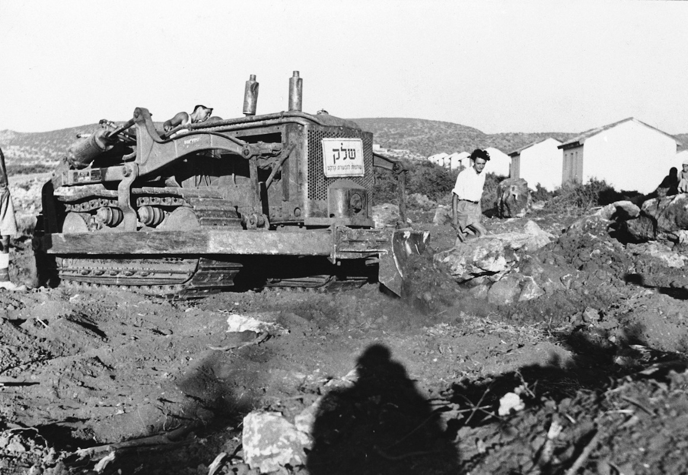
A bulldozer clears land in Palestine to be used by Jewish Yemeni farmers, Sept. 4, 1950. Photo | AP
These enormous tracts of good, arable land were now held by the state and were used by Jewish settlements and individual farmers to grow crops and vegetables. Vacant Arab homes were used to accommodate immigrants. With time, emptied Palestinian villages were either transformed or destroyed. Some were turned into parks and forests; others were used for cultivation and development. “All these measures steadily rendered the possibility of a return of the refugees ever more remote.”
Israel and Zionist spokespeople worldwide like to claim that the Jews came to an empty, barren land and made it bloom. This study makes it clear that they came to an already prosperous country and stole its riches.

The report of the UN Mediator for Palestine
One would be remiss to discuss Palestinian refugees without mentioning the contributions and indeed sacrifice of the UN Mediator to Palestine, Count Folke Bernadotte. Bernadotte was a Swedish diplomat, who after successfully negotiating the rescue of some twenty thousand prisoners from Nazi concentration camps (more than half of whom were Jewish), was asked to take on the role of Mediator for Palestine. He visited the country several times and presented several reports.
Count Bernadotte presented his first report regarding the refugees to the United Nations on September 16, 1948. The report describes his efforts to obtain an agreement from the Provisional Government of Israel for a phased return of refugees. This study clearly states that “attempts at finding a diplomatic solution were unsuccessful because of the firm stance of the Provisional Government of Israel against the return of the refugees.” Bernadotte’s report underscored that:
The right of innocent people, uprooted from their homes by the present terror and ravages of war, to return to their homes, should be affirmed and made effective, with assurance of adequate compensation for the property of those who may choose not to return.”
The Palestinian refugees ‘right’ to return and to be adequately compensated is recurrent in his report, notwithstanding the views expressed by the Provisional Government of Israel. The right of return was considered by Bernadotte to be among the most basic premises for the settlement of the conflict. The following passage of his report still resonates today:
No settlement can be just and complete if recognition is not accorded to the right of the Arab refugee to return to the home from which he has been dislodged … It would be an offence against the principles of elemental justice if these innocent victims of the conflict were denied the right to return to their homes while Jewish immigrants flow into Palestine, and, indeed, at least offer the threat of permanent replacement of the Arab refugees.”
The Mediator not only stressed the right of the refugees to return but also made clear that those rights be affirmed rather than established. This reflected the prevailing consensus regarding the norms of international law when dealing with refugees.
Bernadotte also made it clear that,
The right of the Arab refugees to return to their homes in Jewish-controlled territory at the earliest possible date should be affirmed by the United Nations, and their repatriation, resettlement and economic and social rehabilitation, and payment of adequate compensation for the property of those choosing not to return, should be supervised and assisted by the United Nations.”
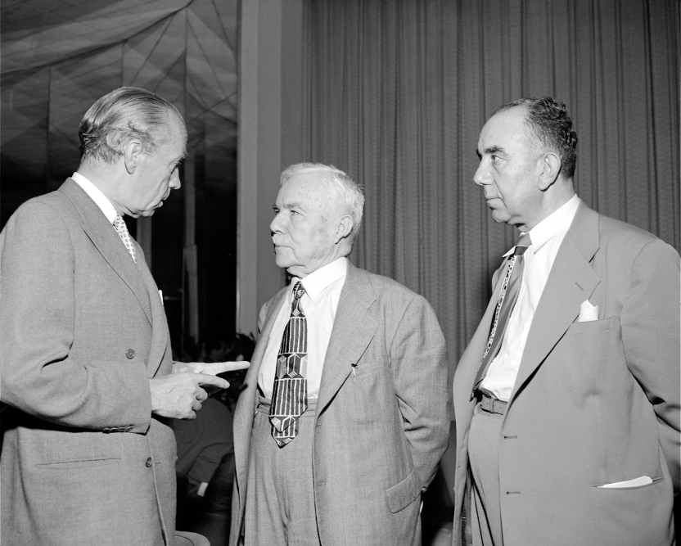
Count Bernadotte, left, speaks with the Syrian leaders at a UN Security Council meeting on July 13, 1948. Photo | UN Archive
Bernadotte’s advocacy for the Palestinian refugees and his claim that Jerusalem – by then occupied and subjected to a thorough ethnic cleansing campaign – should come under international control and not Zionist control could not be tolerated by the Zionist government in Palestine. On September 17, 1948, one day after he submitted his progress report, Folke Bernadotte was assassinated in a terrorist attack by members of a Zionist militia.
The terrorists acted on an order to get rid of Bernadotte, and although it was later claimed that the assassins were part of a fringe extremist group and that the central provisional Zionist government formally condemned the assassination, there is little doubt that the entire Zionist established was complicit in Bernadotte’s murder.
Although the assassins were well known and had even given interviews, none were ever brought to justice. One of the people known to have been directly involved in the assassination was Yitzhak Shamir, though he was not a part of the terrorist squad that committed the murder. Shamir went on to serve in many important Israeli government posts, including Prime Minister.

Resolution 194
The UN General Assembly accepted Bernadotte’s recommendations when it adopted Resolution 194, and as a result of his death, established the United Nations Conciliation Commission for Palestine (UNCCP), which took over the main functions of the Mediator. Concerning refugees, the resolution states that the General Assembly:
Resolves that the refugees wishing to return to their homes and live at peace with their neighbors should be permitted to do so at the earliest practicable date, and that compensation should be paid for the property of those choosing not to return and for loss of or damage to property which, under principles of international law or in equity, should be made good by the Governments or authorities responsible;
Following Israel’s refusal to comply with the Mediator’s request to allow refugees to return to their homes, in paragraph 11, the General Assembly stressed that it,
Instructs the Conciliation Commission to facilitate the repatriation, resettlement and economic and social rehabilitation of the refugees and the payment of compensation, and to maintain close relations with the Director of the United Nations Relief for Palestine Refugees and, through him, with the appropriate organs and agencies of the United Nations.
The work of the United Nations Conciliation Commission for Palestine (UNCCP) was completed in 1964. According to this study, records in the Commission’s archives reveal that it determined the worth of the Palestinian refugees’ privately owned land was 204,660,250 British Palestine pounds, equivalent to $9.6 billion U.S. dollars in 2019.
The study also states that the Commission’s estimates are considered to be “incomplete and conservative,” yet are the most methodologically accurate ones made to date. “Beyond land losses, a compensation regime should also consider movable property losses, disturbance allowance (representing the loss of income until a refugee could re-establish himself/herself), ex-gratia payment representing a general compensation for hardship, and reintegration costs.”
In August of 1961, at the U.S. government’s suggestion, the Commission appointed Dr. Joseph E. Johnson as a special representative. Johnson’s overall estimate of the amount owed to Palestinian refugees for compensation was $1.377 billion U.S. dollars in 1962. This is equivalent to $22.975 billion in 2019. All of this is for the refugees of 1948 only.
Resolution 194 is one of the most widely reaffirmed resolutions in UN history. This study states that “resolutions that have been reaffirmed hundreds of times not only confirm long-established international consensus but they acquire a legal character.” Resolution 194 has been repeatedly reaffirmed over the years, and it has even served as a precedent in international responses to other refugee crises.

Military Order 58
In the aftermath of the 1967 Israeli assault and conquest of Arab lands, and immediately after it seized the West Bank, the Israeli army issued Military Order 58. It authorizes the seizure of any property held by West Bank residents who were outside the area on June 7, 1967, and that of those who subsequently left. “Military Order 58 replicates the Absentees’ Property Law of 1950 for the 1967 territories, applying it to territory that Israel supposedly “merely occupies and over which it has no sovereignty.”
According to this study, Military Order 58 “has a broader scope than the Absentees’ Property Law,” in that it allowed Israel to take control over property that had been held by Jordan since 1948 and placed it under the control of the Custodian’s authority of Israel. Furthermore, it has no time restrictions, covers any Palestinian who leaves the West Bank, and remains in force to this day.
Learning From the Past: History Provides Clues into Israel’s West Bank Annexation
Plans by Israel to carry out the annexation of the West Bank are causing a stir, but Israel has done this before writes Miko Peled.
International law
The British government initially made two conflicting promises regarding Palestine, one to the indigenous Palestinian Arabs and the other to the immigrant-colonizer Jewish community. However, the British government’s actions made it clear that Britain favored the creation of what became known as a Jewish state – or more accurately, a Zionist state – in Palestine. As a side note, it is worth mentioning that the local Orthodox Jewish community residing in Palestine at the time vehemently opposed the Zionists and the creation of a Zionist state. They made their opposition known to the British, the United Nations, and the local Palestinian Arab leadership, with whom they had excellent relations.
British support for Zionist claims to Palestine allowed the all-out military assault by Zionist militias against the indigenous Palestinian community. This ultimately led to the creation of an independent Zionist state and the subjugation, dispossession, exile, and statelessness of indigenous Palestinian Arabs. It also brought about measures preventing the return of the Palestinians forcibly displaced while actively promoting Jewish immigration under the guise of return. As a result of this, there is currently an unresolved refugee crisis “that has evolved into the largest and most protracted in modern history.”
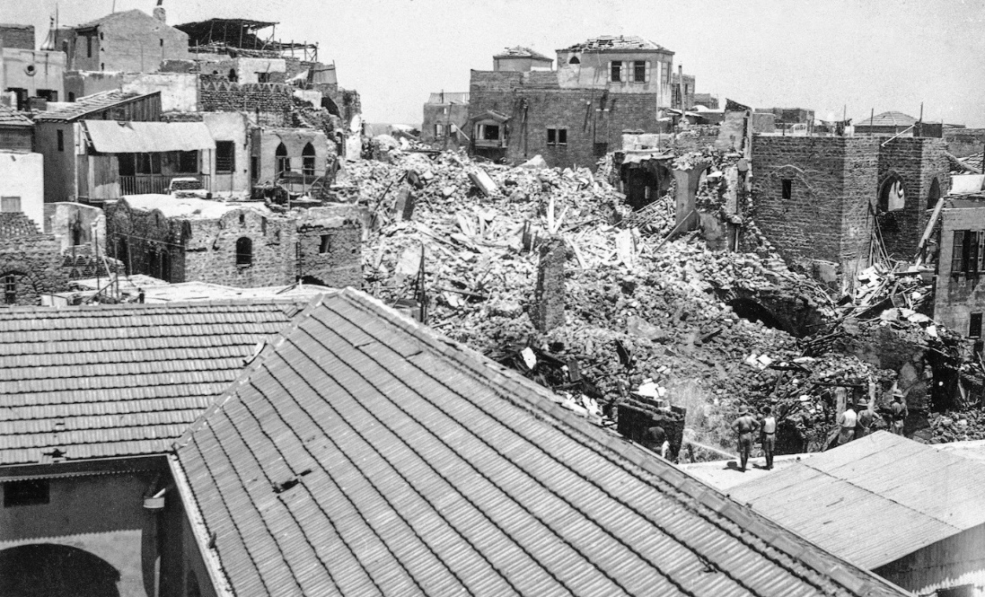
Palestinian homes destroyed with dynamite by British troops following clashes between Jewish militias and Palestinians in Jaffa on July 3, 1936. Photo | AP
A crucial point that must be recognized is that the rights of Palestinian refugees to return, restitution, and compensation, were already enshrined in international law in 1948. The UN General Assembly reaffirmed these rights in resolution 194.
In 1948, the refugees already had the right to return to their homes. Instead, 750,000 refugees were denationalized en masse, prevented from returning to their houses, and forced into a seemingly endless exile. In other words, Israel had already violated its obligations under international humanitarian law and the law of state responsibility in 1948.
Since then, the policies and practices of successive Israeli governments continue to prevent the return and self-determination of Palestinian people. Israel denies Palestinian refugees the right to return, restitution, and compensation, and Israeli leaders even continue to deny the very existence of a Palestinian people. Israel justifies its actions by challenging the foundation of its obligations and that of the rights of Palestinians, and the international community has been weak and unwilling to intervene.
The practice that has evolved since the Second World War affirms that individual and collective claims of refugees are not mutually exclusive but rather reinforce each other. In fact, these are challenges found in other cases of mass displacement, serious human rights violations, and where the passage of time has increased the number of claimants. The high number of possible claimants among Palestinian refugees is often seen as justifying Israel in its refusal to recognize Palestinian refugees’ rights in general. However, given the clarity of the individual rights and the nature of violations involved in the Palestinian case, “individual claims and claims en masse for groups of individuals must be addressed.”
These are issues that can be overcome, as was demonstrated by the reparations to victims of Nazi persecution. They included multiple claims in different jurisdictions within different countries and on different continents, with settlements being achieved many decades after the violations took place.
The Israeli government aggressively encourages Jews from around the world to settle in Israel while pressing for restitution laws to be adopted regarding losses suffered by the Jewish people. Simultaneously, it adamantly denies Palestinians the right to return and resettle in their homeland and receive restitution. Being that Israel is a settler-colonial state these policies are not unusual, one wonders, however, at what point the international community will intervene on behalf of the millions of Palestinian refugees waiting to retun.
Right to return
Israel objects to the return of the Palestinian refugees claiming it is an existential threat. However, what Zionist institutions fear equally as much are demands under international law that they pay restitution and compensation for the properties both private and public, and for the natural resources stolen from the Palestinian people.
In 1949, the Geneva Convention elaborated regarding the prohibition of deportation and expressly referred to the repatriation of protected persons. Article 49 of GCIV prohibits “individual or mass forcible transfers, as well as deportation of protected persons from occupied territory.” It goes on to say that “All protected persons who may desire to leave the territory at the outset of, or during a conflict, shall be entitled to do so.”
Zionist institutions and spokespeople claim that the refugee issue has somehow reached some imaginary statute of limitations. However, the legal foundation of the rights of the Palestinian refugees to repatriation, restitution, and compensation – as affirmed in resolution 194 – not only has not expired but, according to this study, “has since become even stronger.” Furthermore, according to the Articles on State Responsibility, “the state responsibility does not diminish with the passing of time.”
It is only for political reasons that the rights of the Palestinian refugees continue to be side-lined. Zionist institutions around the world, with the support of the United States government, are doing all they can to undermine the severity of the Palestinian refugee issue and to absolve Israel of any responsibility. The fall of the Zionist- apartheid regime in Palestine and the emergence of a free and democratic Palestine in its place is arguably the only development that can realistically bring about the return of the refugees.
++++++++++++++++++++++++++++++++++++++++++++++++++++++++++++++++++++++++
https://www.mintpressnews.com/oxford-study-reveals-stunning-truths-about-palestinian-refugee-question/272023/

