ISRAEL USES PALESTINIAN LAND TO ILLEGALLY DUMP TOXIC WASTE
THURSDAY, DECEMBER 14, 2017 AT 07:51PM
https://electronicintifada.net/blogs/tamara-nassar/israel-uses-palestinian-land-illegally-dump-toxic-waste
by Tamara Nassar 7 December 2017 The Electronic Intifada
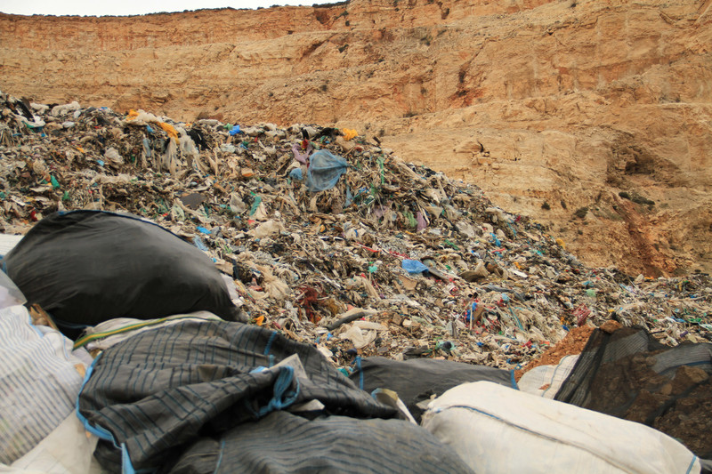
Israel dumps unknown waste and military garbage in a disposal site in Kisan village, in the occupied West Bank, 4 February 2014. Ahmad Al-Bazz ActiveStills
Israel has turned the occupied West Bank into a dumping ground for its waste in violation of international law.
“Israel’s environmental policy in the West Bank, including situating polluting waste treatment facilities there, is part and parcel of the policy of dispossession and annexation it has practiced in the West Bank for the past 50 years,” a new report by human rights group B’Tselem says.
“Israel is exploiting the West Bank for its own benefit, ignoring the needs of the Palestinians almost entirely, and harming both them and their environment.”
Palestinians in the West Bank, unlike Israeli settlers living in neighboring illegal settlements, have no influence on Israel’s decisions to operate waste treatment facilities on their land.
Israel abuses its status as an occupying power to impose these facilities on Palestinian communities, completely disregarding the hazards they pose.
Israel dumps sewage sludge, infectious medical waste, oils and solvents, electronic waste and used batteries, among other materials.
“All of these are urban and industrial by-products Israel generates within its own territory, and they are made up of a wide range of unwanted substances that pose a real threat to the people and natural resources in their vicinity,” the report states.
Israel also makes it profitable for corporations as it “offers financial incentives such as tax breaks and government subsidies” to operate waste plants in the West Bank rather than within Israel.
Israel’s ecological footprint – a measure of a country’s resource consumption and environmental impact – is three times that of neighboring Egypt, Syria or Jordan.
But Israel diverts much of the pollution it produces by transferring it to the West Bank.
Compared to other countries, Israeli legislation is highly negligent of the risks posed by these hazardous operations.
“The current framework does not address medical waste nor the risks it involves,” according to B’Tselem.
"Sacrifice Zones"
Due to “internal objections to local treatment plants” as well as high costs of exporting waste internationally, Israel started seeking “sacrifice zones” – areas that are “irrevocably impaired” by environmental and economic neglect.
Israel created such zones in the West Bank, where it currently operates at least 15 waste plants.
One of them is the facility operated by Elidori Green on confiscated lands near the Palestinian village of Kisan.
Elidori Green, an Israeli company, operates a dump for construction waste with the complicity of at least two international firms, depending on equipment made by Canada’s McCloskey International and Sweden’s Volvo Trucks.
Six of the sites handle hazardous waste that would typically require special regulations due to the environmental danger they pose.
But Israel’s environmental policy in the West Bank differs from the one inside Israel.
Despite being a signatory to the Basel Convention, an international treaty setting standards for handling and transporting hazardous waste to economically disadvantaged areas and countries, Israel fails to maintain these standards in its West Bank facilities.
The treaty stipulates that hazardous waste is only transported to countries that are given detailed information about what they’re receiving and are able to manage the waste to specific environmental standards. Most importantly, receiving countries must provide written consent.
Israel considers the West Bank its own territory, and therefore assumes none of these requirements apply.
Palestinians are never asked for consent to receive the waste or provided detailed information regarding what is being dumped near their communities.
Israel also fails to supervise or inspect waste operations in the West Bank, and does not hold them to the same rigorous environmental standards that it does in Israeli cities.
In fact, Israel conceals most information about the amount of waste dumped and companies are not required to disclose “the hazards their operation poses or the measures they adopt to prevent – or at least to reduce – these risks.”
“Israel is effectively having it both ways,” the report concludes, “seemingly increasing the amount of waste it treats, [but] it actually does so by diverting the risks and pollutants onto Palestinian land and people.”

