

Ariel Koren, an anti-zionist Jewish tech worker, just resigned from Google in protest. Her resignation letter explicitly called out Google’s retaliation against and silencing of Palestinian, Muslim, Arab, Jewish anti-Zionist, and other allied workers speaking up for Palestinian freedom.

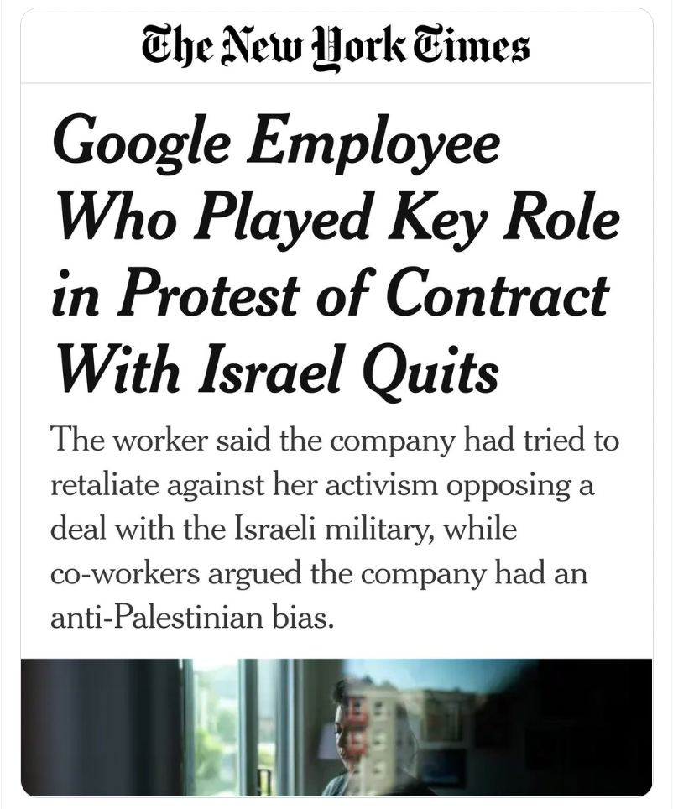

Today, an investigation in The New York Times featured interviews with workers like Ariel, who are speaking out against a $1 billion contract with the Israeli military and apartheid government. This contract, also known as Project Nimbus, can help the Israeli military to surveil and harm Palestinians. Koren’s resignation letter, quoted by the Times article, explained:

“Google systematically silences Palestinian, Jewish, Arab and Muslim voices concerned about Google’s complicity in violations of Palestinian human rights — to the point of formally retaliating against workers and creating an environment of fear.”

Palestinian workers at Google also describe the retaliation they’ve faced. “Project Nimbus makes me feel like I am making my living off my family’s oppression,” one of them said. But if they speak out, they face accusations of antisemitism and threats of termination from Google.

Read and share our tweet thread on the NYT article

Tech workers at Google and Amazon are risking their jobs to organize against corporate contracts that fuel Israeli apartheid and state violence, and we need to have their backs. Their demands are clear: either stop profiting off of violence against Palestinians or face a public relations and labor crisis. Google is trying to silence these workers in order to protect their bottom line, but the #NoTechForApartheid campaign is gaining momentum and we are turning up the pressure in solidarity.
Read and share our Twitter thread about this moment in the No Tech for Apartheid campaign and stay tuned for more updates this week.
Stand with tech workers to say #NoTechForApartheid,

Onwards,
Dani Noble
Campaigns Organizer

August 2022

