PALESTINE  HISTORY  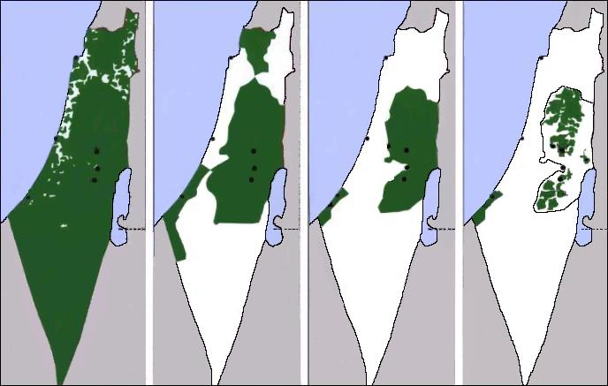  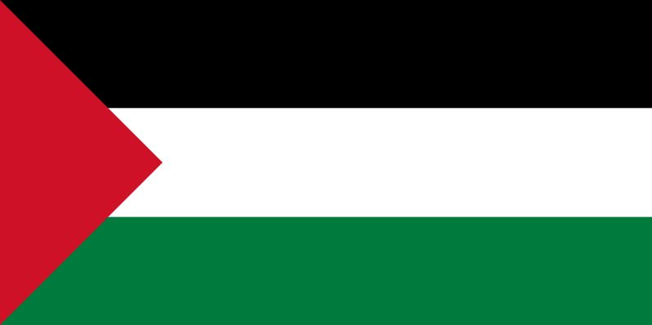  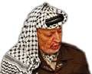  In images – In images – In images  The history of Palestine (full and short version)  The live behind the wall;  THE WALL - Gaza 2009  PowerPoint  Several documents about Palestine (Word/PDF) | PALESTINE  HISTORY  In images – In images – In images  The history of Palestine (full and short version)  The live behind the wall;  THE WALL - Gaza 2009  PowerPoint  Several documents about Palestine (Word/PDF)
PALESTINE  HISTORY  In images – In images – In images  The history of Palestine (full and short version)  The live behind the wall;  THE WALL - Gaza 2009  PowerPoint  Several documents about Palestine (Word/PDF) | PALESTINE  HISTORY  In images – In images – In images  The history of Palestine (full and short version)  The live behind the wall;  THE WALL - Gaza 2009  PowerPoint  Several documents about Palestine (Word/PDF)
PALESTINE  HISTORY  In images – In images – In images  The history of Palestine (full and short version)  The live behind the wall;  THE WALL - Gaza 2009  PowerPoint  Several documents about Palestine (Word/PDF) | PALESTINE  HISTORY  In images – In images – In images  The history of Palestine (full and short version)  The live behind the wall;  THE WALL - Gaza 2009  PowerPoint  Several documents about Palestine (Word/PDF)

