  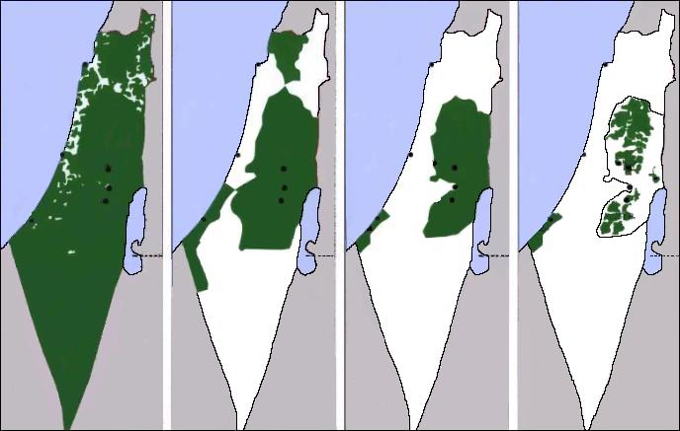  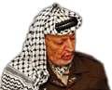  HISTORY OF PALESTINE  In images – In images – In images  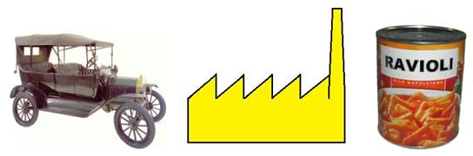  SOCIO-POLITICAL BASIC FORMATION  The current economic system  and the alternatives  PowerPoint |  | HISTORY OF PALESTINE  In images – In images – In images  SOCIO-POLITICAL BASIC FORMATION  The current economic system  and the alternatives  PowerPoint
 |  | HISTORY OF PALESTINE  In images – In images – In images  SOCIO-POLITICAL BASIC FORMATION  The current economic system  and the alternatives  PowerPoint | STORIA DELLA PALESTINA  In immagini – In immagini  FORMAZIONE SOCIO-POLITICA DI BASE  Il sistema economico attuale e le alternative  PowerPoint
  HISTORY OF PALESTINE
  In images – In images – In images
  SOCIO-POLITICAL BASIC FORMATION
  The current economic system
  and the alternatives
  PowerPoint
  STORIA DELLA PALESTINA
  In immagini – In immagini
  FORMAZIONE SOCIO-POLITICA DI BASE
  Il sistema economico attuale e le alternative
  PowerPoint
  HISTORY OF PALESTINE
  In images – In images – In images
  SOCIO-POLITICAL BASIC FORMATION
  The current economic system
  and the alternatives
  PowerPoint
  STORIA DELLA PALESTINA
  In immagini – In immagini
  FORMAZIONE SOCIO-POLITICA DI BASE
  Il sistema economico attuale e le alternative
  PowerPoint
  HISTORY OF PALESTINE
  In images – In images – In images
  SOCIO-POLITICAL BASIC FORMATION
  The current economic system
  and the alternatives
  PowerPoint
  STORIA DELLA PALESTINA
  In immagini – In immagini
  FORMAZIONE SOCIO-POLITICA DI BASE
  Il sistema economico attuale e le alternative
  PowerPoint

