The Palestinian Conflict
1

A Metaphor for understand the problem

Dear Reader

Let's suppose that you, your wife, your five children and your parents are living in a nice two floor house. Your home has a car box and a small handicraft business attached, a garden, a field and a stable with some cows. It is your family’s property since ages and where you make a living with your handicraft business and by growing crops and farming your cows.

One day a man comes up and asks you if he could stay at your place for some days with his family. You let them in the guest room at the ground floor. He pays you a small rent. As time goes by They (your guest and his relatives) grow bolder and start using your laundry, then your garden, then also your car, and then they stop paying you the rent.

One day your patience comes to end. You call them to order but they threaten you with killing. You're scared and search shelter at your cousin's. While you are absent They (the zionists) make themselves comfortable on the first floor. When you are back they don't let you in. You have no other choice but to stay at the guest room on the ground floor. If you go upstairs to the first floor They hit you. As it wouldn't be enough, They also shoot at you and kill one of your sons. You call the police, but you're answered that they have no time.

One day They start using your laboratory. They also expand it. With their ability, their international relations and the underpaid labor of two of your sons they make a small factory out of your former business.

One day relatives of Theirs arrive. They suffered difficult times and are in trouble. Needless to say, you are forced to free the guest room and move to the garage. Your sons have to sleep in a tent and your parents camp on the road.

One day you are so fed up that try to get them out by force: you kill one of their sons, but They fire back and kill another one of your sons, und They also damage your garage and destroy your tent. In the mean time in your home and in the neighborhood any trace of yours has been removed and replaced by the emblem of Their family, which sticks on everything. You call the police (the English), but they don't know what to do because they also fear Them und they suggest you to go stay at your cousin's.

One day the issue ends up at court (UN) : unashamed They affirm that the property is theirs because nobody lived there when they arrived, their ancestors already lived there 2000 years ago with the help of God, They transformed the once dry land into a green garden, They created a solid industry and now, thanks to Them, everything is tidy and clean. They do not forget to remind of their brothers who got killed by the gangsters (the Nazists) in a foreign country. You too are a believer, but They, lying, claim that God is on their side, not yours, and yours is but a pure religious dispute.
Considering the current situation and facing the fact that They destroyed the land registers and all kind of documents, the judge “impartially” decides that the house and the laboratory belongs to Them, the garden, the car box, the field and the stable to you.
Them as next they kill the judge's supervisor (Bernadotte) and raise a fence overnight to prevent you from accessing the stable and the field. You helplessly look at them milking your cows and using your equipment.
You become furious and want to conquer back your house with the help of friends and neighbors (Egypt, Jordan, Syria, Lebanon). But They fight back and hit everyone, and on top They occupy all the property and the neighbors' vegetable-gardens (the Sïnai + Golan) to also get their vegetables.
Back again at court the judge grants the permission to your sons to stay in the guest room. You are allowed to stay in the car box, but you have to repair it at your own expense.
They employ to your sons in the stable from time to time.

One day, with the help of a powerful friend (the US), and by alternating threats with the promise of giving back a part of the vegetable-garden, They convince your neighbors to no longer help you. In the meantime They work steadily at your definitive expulsion: to convince you to leave They destroy the car box where you live, check your mail and your phone calls, watch any move of yours, seize your car, smash your TV set…. They finance all of these interventions with the taxes they collect from you to pay Their administration. And as if this is not enough, they also receive an indemnity for the death of their brothers abroad. You are reduced in misery, and They prosper.
The judge gives you a tent as a gift and grants a miserable indemnity to your parents, who are living in a temporarily but definitive shelter on the land of one of your neighbors Two of your sons live as good as they can at the ground floor, while your third son has emigrated abroad and sends you at intervals some money.

One day They put a gate at the entry of your garden and one at the entrance of the house. You can neither visit your sons nor your parents; you can not even go to work, to the market, to school or to the hospital. Your parents and your emigrant son are denied entrance. In the meantime, other relatives of Theirs arrive and stay in a camper parked in the garden. Saying that he can became dangerous They kill your faithful dog.

One day you give in and admit your defeat. You renounce to your house and accept it is now Theirs in change of the possibility of living in freedom in the garden and of rebuilding the garage. They say they are glad you finally admitted that They are the legitimate owners of the properties, but they demur on the others subjects. Unfortunately, in the meantime some of Them swear at you, destroy your tent again, chop the olive trees from which you got your income and turn off the water supply. They also “generously” offer you to settle down in a corner of the garden under their control.

One day, because the situation degenerates and becomes unbearable: you take a gun, shoot at the house and wound one of them. They reply by killing another son of yours, hit you, imprison you in the closet, state that you’re a dangerous terrorist and declare that They no longer talk to you until you get reasonable. And on top of this your wife blames you for your ineptitude and threatens to hit here own road and leave you alone.

One day, at the top of desperation your son starts throwing stones at Them. Their reply with rifles, cannons, bombs, helicopters, tanks, prohibitions, controls, destruction and imprisonment with a high separation wall. The public opinion only gets one-sided information (Their side), think that you’re violent and refuse to help you. Many people, including the judge, keep silent because they are afraid of Their powerful friend, or feel sorry for the slaughter of their brothers in another land.
Someone starts saying that you just create disorder, that helping you is too expensive, that you should have accepted their generous offer and that maybe it would be better that you go away.
Others stigmatize the situation but do not dare an intervention, others simply have no interest.

Dear Reader: if you are in this miserable condition you can be nobody else than a Palestinian.
Who are the other “actors”? They are the Zionists, the police are the English during the mandate, the judge is the UN, the people (public opinion) are the international community, the neighbors are Egypt, Jordan, Syria, Lebanon, their powerful friend the US, the wife is Hamas, …
Now how can we convince Them to give back the stolen goods, or at least allow an acceptable cohabitation?

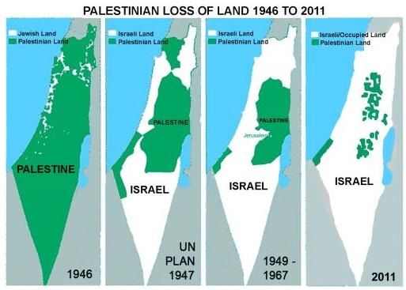

Look and free download the presentations: "History of Palestine in images" and
"The current economic system and the alternatives" from the socio-political basic training website www.imparalavita.ch

Our organization: ……..

