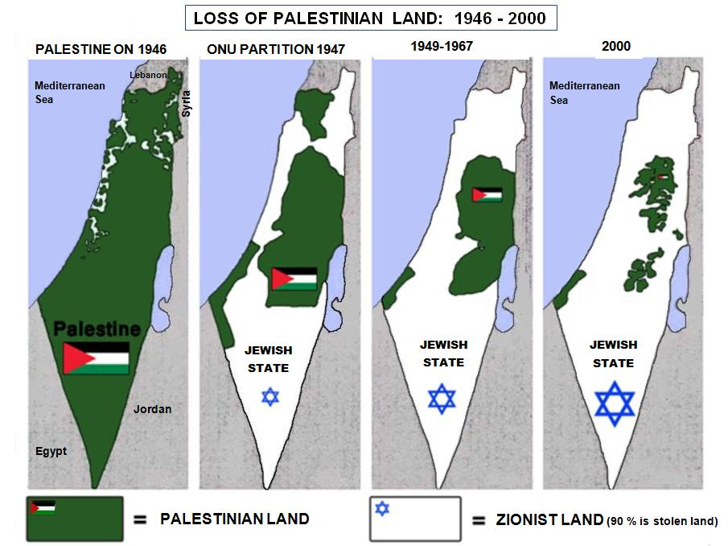
Gaza
Westbank

In order to constitute a state for Jews only (Zionism), since 1900 the Zionist Jews began the conquest and colonization of Palestine. In 1948, in defiance of UN Resolution 181, 700,000 Zionist Jews forcibly expelled 800,000 Palestinians (two thirds of the Arab inhabitants) and they confiscated the property and the land of the Palestinians. With the war of 1967 the Zionist Jews occupied all Palestine and began the ethnic cleansing and colonization also of the part that was remained to the Palestinians. Today in Palestine live 6 million Palestinians. 4.5 million Palestinians living in refugee camps (in Palestine and abroad) and are dependent on the UN. Today in Israel, in occupied Palestine and on the Golan live about 6 million Zionists Jews.

The Gaza Strip is a small part of Palestine of 360 km2, situated along the Mediterranean Sea. There lives amassed 1.8 million Palestinians, mostly refugees since 1948. To crush all resistance, since decades Israel oppresses all the Palestinian people and specially the besieged Gaza Strip, accomplishing brutal bombings and massacres to the point that since years the Gaza Strip is a real concentration camp.

Look and free download the presentations: "History of Palestine in images" and
"The current economic system and the alternatives" from the socio-political basic training website
www.imparalavita.ch

Our organisation: ……………….

