East Jerusalem: Jewish Settlers Seize 15 Palestinian Homes in Silwan
April 8, 2021 Blog, News, Slider
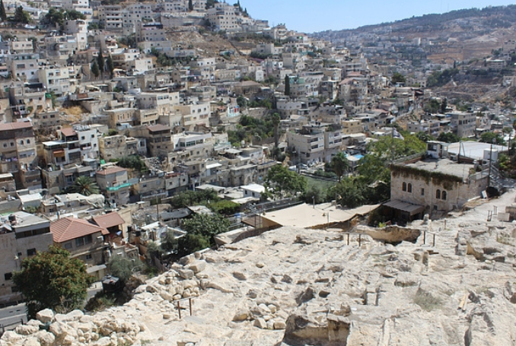The East Jerusalem neighborhood of Silwan. (Photo: OCHA, File)
Jewish settlers seized 15 Palestinian houses in the occupied East Jerusalem district of Silwan, Israel’s Channel 7 reported.
According to the channel, the settlers placed Israeli flags on 15 houses in Silwan after the Ateret Cohanim organization seized them and handed them to settler families.
Ateret Cohanim is a government-backed Jewish group and educational institute located in the Muslim Quarter of the Old City of Jerusalem. It actively works on Judaising the holy city and expelling its indigenous Palestinian residents from their homes.
The channel pointed out that these new seized homes joined 22 others that were recently taken over by Ateret Cohanim.
In 2004, Ateret Cohanim began applying to Israeli courts to enable it to seize Palestinian homes and property and displace local families in Silwan and other neighborhoods in the Holy City.
“While the Israeli State claims to play an impartial role in this scheme, it is actually the facilitator of the entire process,” Palestinian journalist and editor of The Palestine Chronicle Ramzy Baroud wrote in a recent article.
“The final outcome manifests in the ever-predictable scene, where an Israeli flag is triumphantly hoisted over a Palestinian home and a Palestinian family is assigned an UN-supplied tent and a few blankets,” Baroud added.
(Palestine Chronicle, MEMO, Social Media)

