Bedouins - 1951 Documents Reveal Israel’s Intent to Ethnically Cleanse Bedouin from their Lands
CONTACT@IFAMERICANSKNEW.ORG FEBRUARY 8, 2022 BEDOUINS, DAVID BEN-GURION, HAIM LASKOV, HOME DEMOLITIONS, ISRAEL OCCUPATION, L, MOSHE DAYAN, MOSHE SHARETT
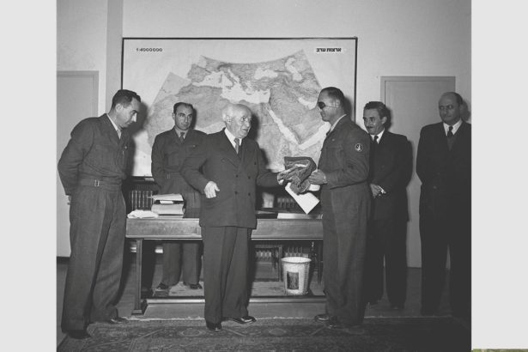
A protest in Jerusalem against home demolitions in Al-Arakib, 2011.Credit: Tomer Appelbaum
What’s left of Al-Arakib is easy to reach. Head south on Route 40, turn right after the Lehavim Junction and you’ll see what looks like ruins. An ancient cemetery may be the clearest evidence of the life still here. At the moment, there’s a tent and two vans here. One van serves more as shelter from the weather than as a means of transportation.
The state has already evicted the Bedouin from Al-Arakib’s roughly 2,000 dunams dozens of times, but they keep coming back and reassemble. Israel then demolishes their homes again.
To a large extent, Al-Arakib’s story is that of the entire Negev Bedouin community. The state doesn’t recognize as theirs the tens of thousands of dunams they once lived on and where they still live.
‘The research proves that what David Ben-Gurion explicitly denied in the Knesset actually happened, and how. There was an organized transfer of Bedouin citizens’
Officially, the Bedouin left during the war and didn’t return, so the state expropriated the land. Then, the Land Acquisition Law of 1953 made this situation permanent. The law states that expropriated land would become state property if its Arab owners, despite still living in Israel, didn’t return to it between May 15, 1948 and April 1, 1952, and if the land was expropriated for “essential development needs” and still served those needs.
The state expropriated 247,000 dunams in the Negev, but 66,000 of them remain unutilized to this day. That underutilization has sparked a wave of Bedouin lawsuits, but the courts have rejected them time after time.
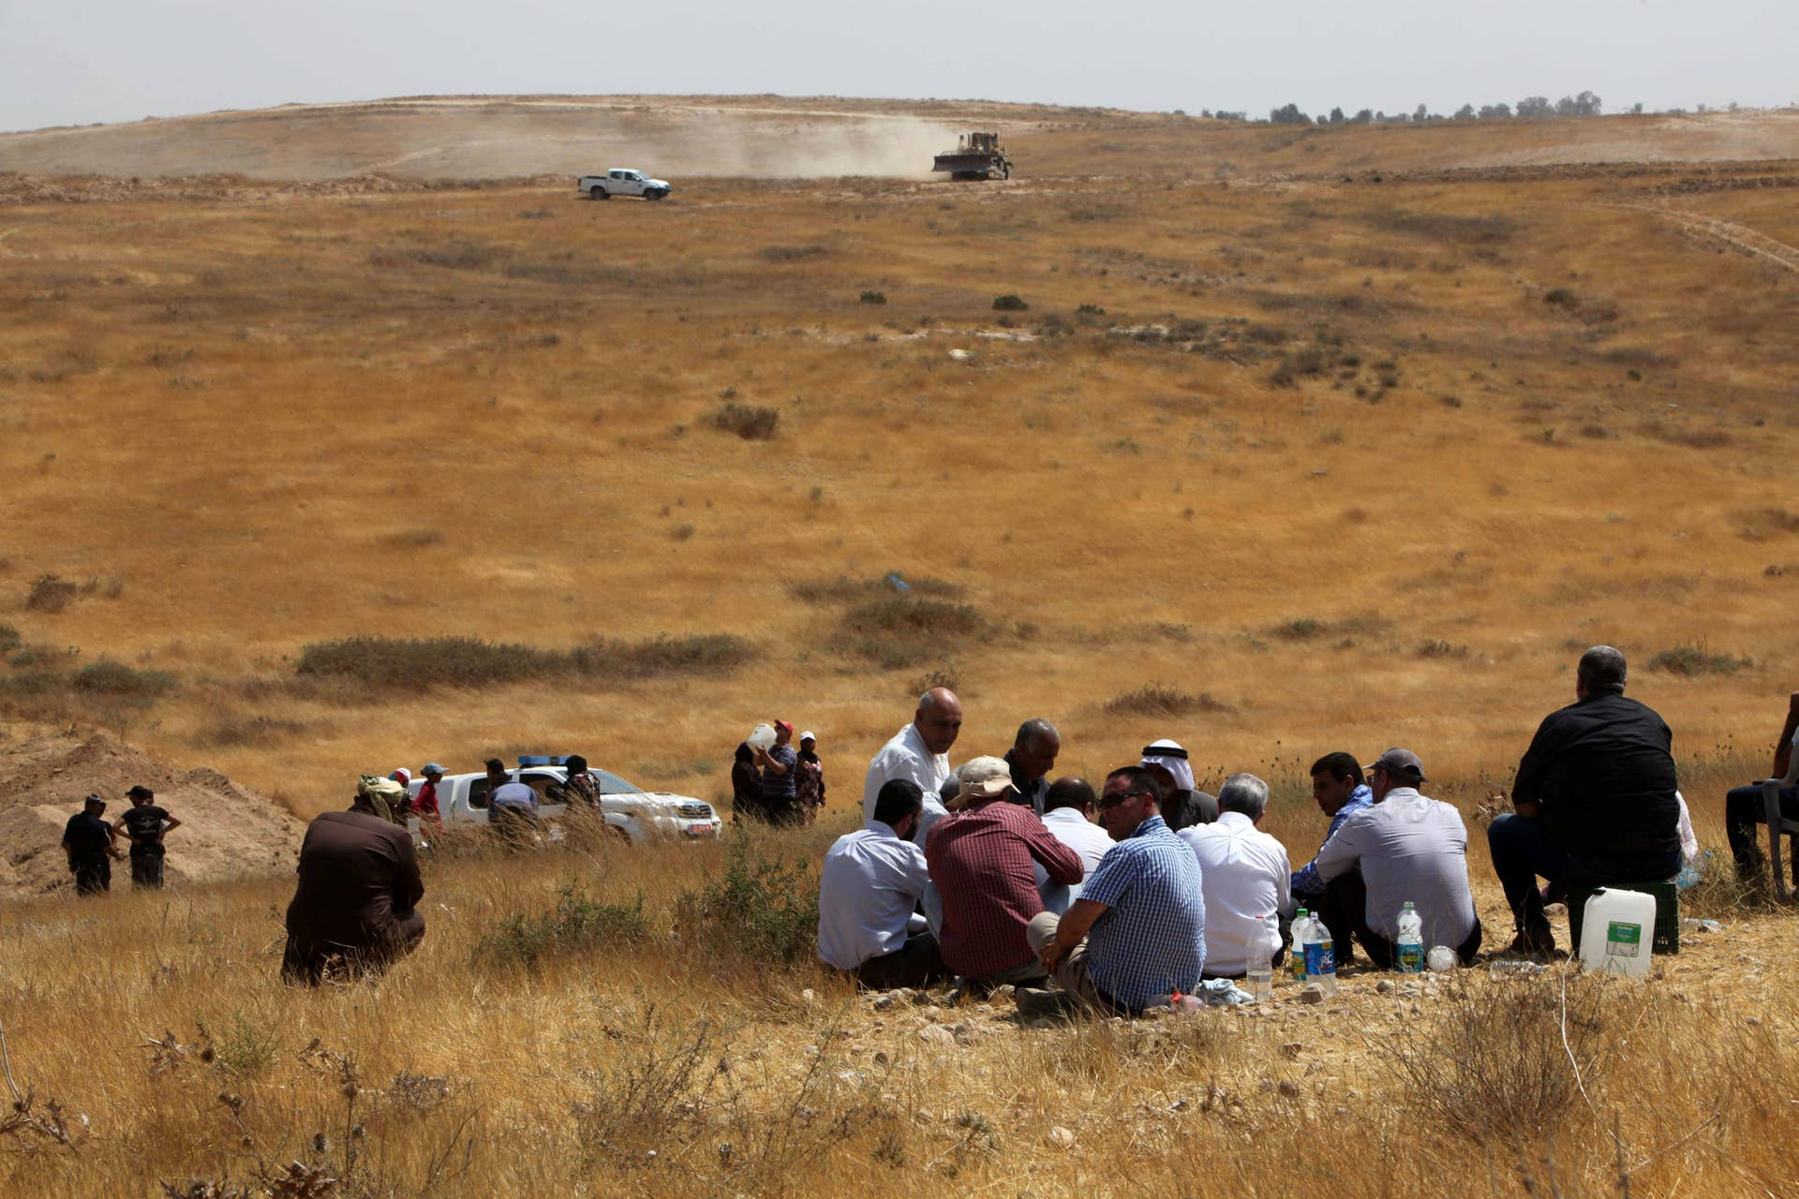
Dr. Awad Abu Freih Credit: Eliyahu Hershkovitz
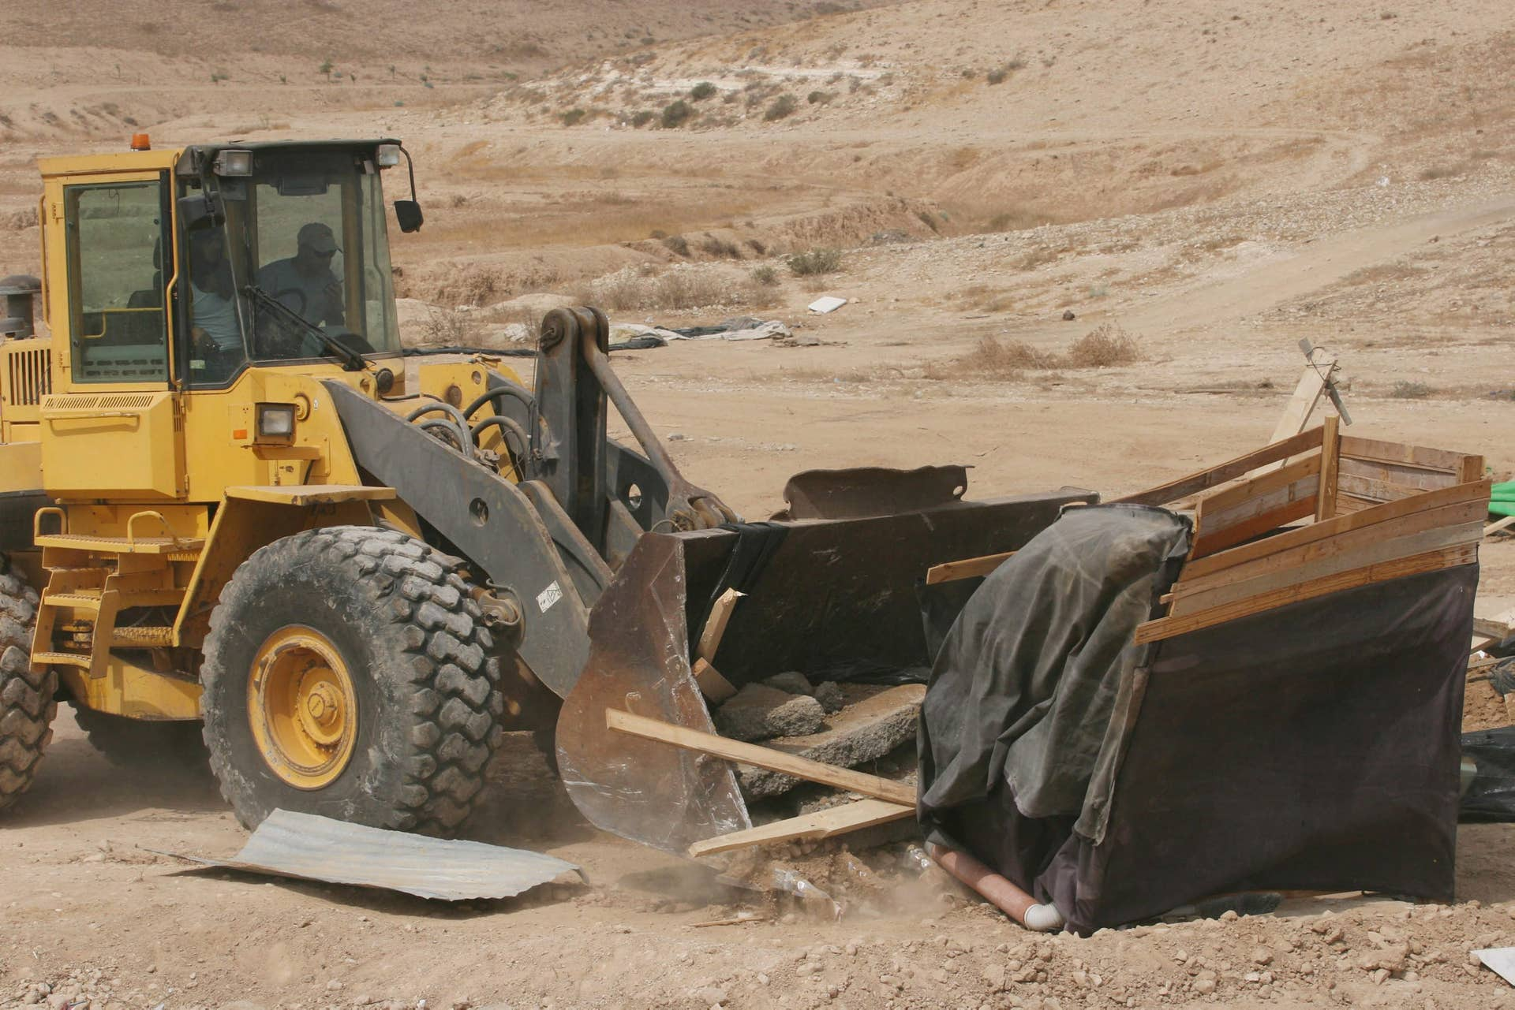
Demolished homes in Al-Arakib, 2014. Credit: Ilan Assayag
Over the past decade, Al-Arakib has become the standard bearer for the Bedouin’ fight for recognized ownership of Negev lands. The state has evicted the residents – who consider themselves the owners but are called squatters – dozens of times.
The narrow opening left by Grunis’ ruling encouraged the Abu Madiam and Abu Freih families now to sue for ownership of Al-Arakib’s 2,000 dunams. They are represented in the Be’er Sheva District Court by attorneys Michael Sfard and Carmel Pomerantz.
Another local tribe filed a similar petition and lost, but that petition lacked Algazi’s findings.
“Even if we don’t win, heaven forbid, I’ve achieved my goal,” said Dr. Awad Abu Freih, the head Sapir College’s biotechnology department and the lead plaintiff. “The history has been told, and also written. My story, that of my father and my grandfather, won. This isn’t just another case, just another name. This is Al-Arakib, which has insisted on continuing to live and refused to die, even if they buried us alive.”
Algazi’s research reveals for the first time the large-scale operation to evict the Bedouin and move them elsewhere in the Negev that Southern Command launched in November 1951, with approval from Chief of Staff Yigael Yadin. The eviction had security justifications, but it also had another goal – severing the Bedouin’s ties with their lands.
“The research proves that what David Ben-Gurion explicitly denied in the Knesset actually happened, and how,” Algazi told Haaretz, referring to Israel’s first prime minister. “There was an organized transfer of Bedouin citizens from the northwestern Negev eastward to barren areas, with the goal of taking over their lands. They carried out this operation using a mix of threats, violence, bribery and fraud.”

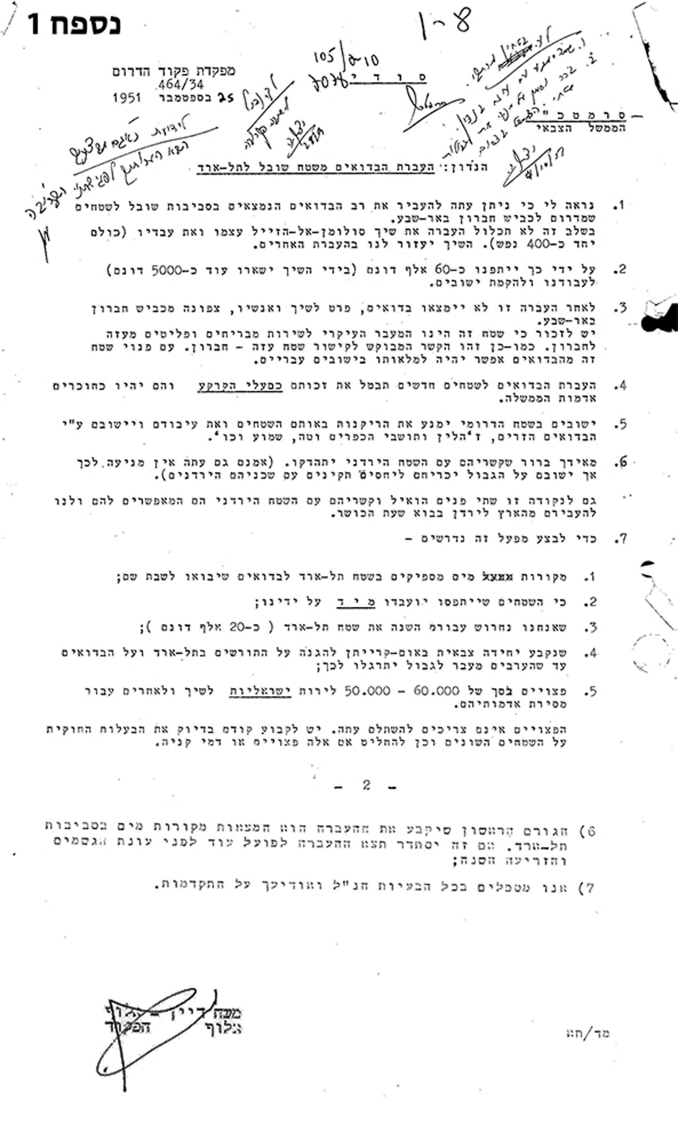An aerial view of al-Arakib from a British airplain in 1945, using 3D imagery from Forensic Architecture. Credit: Forensic Architecture
Dayan raised security considerations in favor of moving the Bedouin to the area of the Jordanian border, but security was not the only consideration. “Transferring the Bedouin to new territories will annul their rights as landowners and they will become tenants on government lands.” Dayan made a similar statement a year earlier, in June 1950, during a meeting of Mapai. “The party’s policy should be aimed at seeing this community of 170,000 Arabs as if their fate has yet to be sealed. I hope that in the coming years, we will be able to transfer these Arabs out of the Land of Israel.” A year after expressing this aspiration, the documents reveal, he partially executed his plan, moving them within but not outside the state’s borders.
Dayan’s letter was not easy to find, says Algazi. “In November 2017, a huge, disorganized file of correspondence of the military government, containing 1037 pages, was released for viewing,” he recalls. “The scanned file was once a big fat, disorderly folder lying on a dusty shelf somewhere full of correspondence, some interesting, some boring. I scrolled down the screen in the archive and the file got stuck on page 999. It was probably just a simple technical error – somebody didn’t think there’d be files any longer than that.”
Algazi was told the file would be fixed. Two years later, he was informed it was. “Dayan’s letter turned up in the final 40 pages along with another two parts of the correspondence that completed the missing puzzle pieces,” he recalls. “I was sitting in the archives, and I could hear Dayan speaking. In his unique style, he said openly things that others would wrap in cellophane paper: ‘Transferring the Bedouin to new territories would annul their rights as landowners and make them tenants on government lands.’ Clear and simple.”
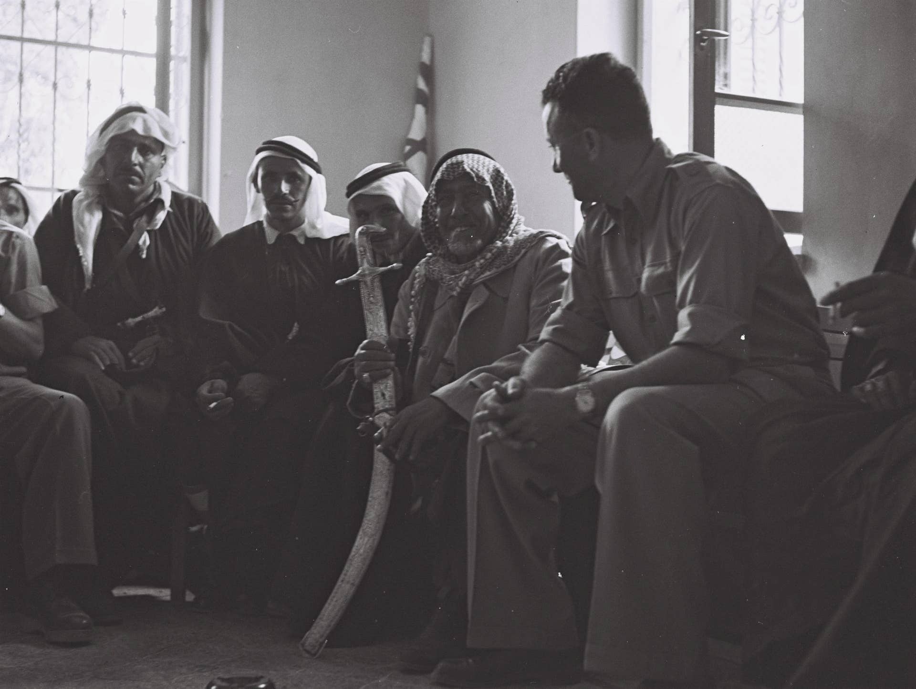
Gadi Algazi at a protests against home demolitions in Umm al-Hiran in 2015. Credit: Eliyahu Hershkovitz
Not everyone in the military supported the operation. The Negev governor, Lt. Col. Michael Hanegbi, wrote to the chiefs of staff that “the presence of the Bedouin in the area serves as a buffer against attacks by infiltrators from the east against our settlements along that line. The fact is that our settlements in this area hardly suffer from attacks, which are very frequent in other areas.” He also warned that the alternative lands designated for the Bedouin were barren and that “the problem of water is the eastern region was getting worse.” On another occasion, Hanegbi reported that “despite restrictions prohibiting the use of violence, attempts were made, with the agreement of command, to try and force them to move.” He added: “A military government unit took down a number of tents and loaded them on to a vehicle. The tent owners did not leave and did not join their families who had been transferred.”
Additional testimonies to events were received from residents of nearby kibbutzim. The area “was surrounded by police and military government in military vehicles,” Yosef Tzur of Kibbutz Shuval wrote to kibbutz movement leaders. “People fled, tents were taken down and those who were caught were piled into vehicles and taken to Tel Arad.” A little of what happened when the uniformed officers turned up was revealed by Sheikh Suleiman Al-Okbi in an interview with Yedioth Aharonoth in 1975. “Military units began turning up on our lands from time to time and they would shoot in the air,” he told Yedioth. “People were scared and the women were frightened to work in the field and graze the animals.”
Lieutenant Colonel Hanegbi wrote in one of his letters that “the transfers were conducted primarily through persuasion and economic pressure.” He went on to reveal more. “We had no legal foundation and we were also under orders not to use force, so we had to behave cautiously in our actions and without becoming entangled in legal problems.”
Algazi found evidence of this economic pressure in a note written by the prime minister’s advisor on Arab affairs back then, Yehoshua Palmon (who, the researcher says, was “the most senior figure in setting policy toward Israel’s Arab citizens”). Palmon wrote that the military government prevented the Bedouin from sowing their lands to pressure them into agreeing to move. There was evidence of this practice on the ground. Kibbutz Shuval wrote to the Mapam Party on January 28, 1952, that “the military government forced the Bedouin to leave their lands. Their food supplies were stopped.” According to the kibbutz residents, food supplies were stopped over a period of months.

Families protesting against renewed work to evacuate Al-Arakib in 2016. Credit: Eliyahu Hershkovitz
“We felt a duty to emphasize that this was being done through conspiracy, bribery, and pressure,” they wrote, reporting that “some tents were moved by force.” The kibbutzim’s protest led Mapan to investigate the matter in November 1952. Lieutenant Colonel Hanegbi testified that he had only carried out the orders given him, but confirmed that the army’s intention was to “undermine the status of the tribes being transferred, so they would leave the country.” As part of the operation, he said, “scare tactics and bribery were used, but not always.” Hanegbi contended that military personnel had behaved “cruelly and crudely” toward the Bedouin. As a result, a recommendation was made to annul his party membership.
Algazi says that while there have been a number of studies in recent year about the period of military rule, “there was no study or affirmation until today that the 1951 deportation took place.”

A matter of timing
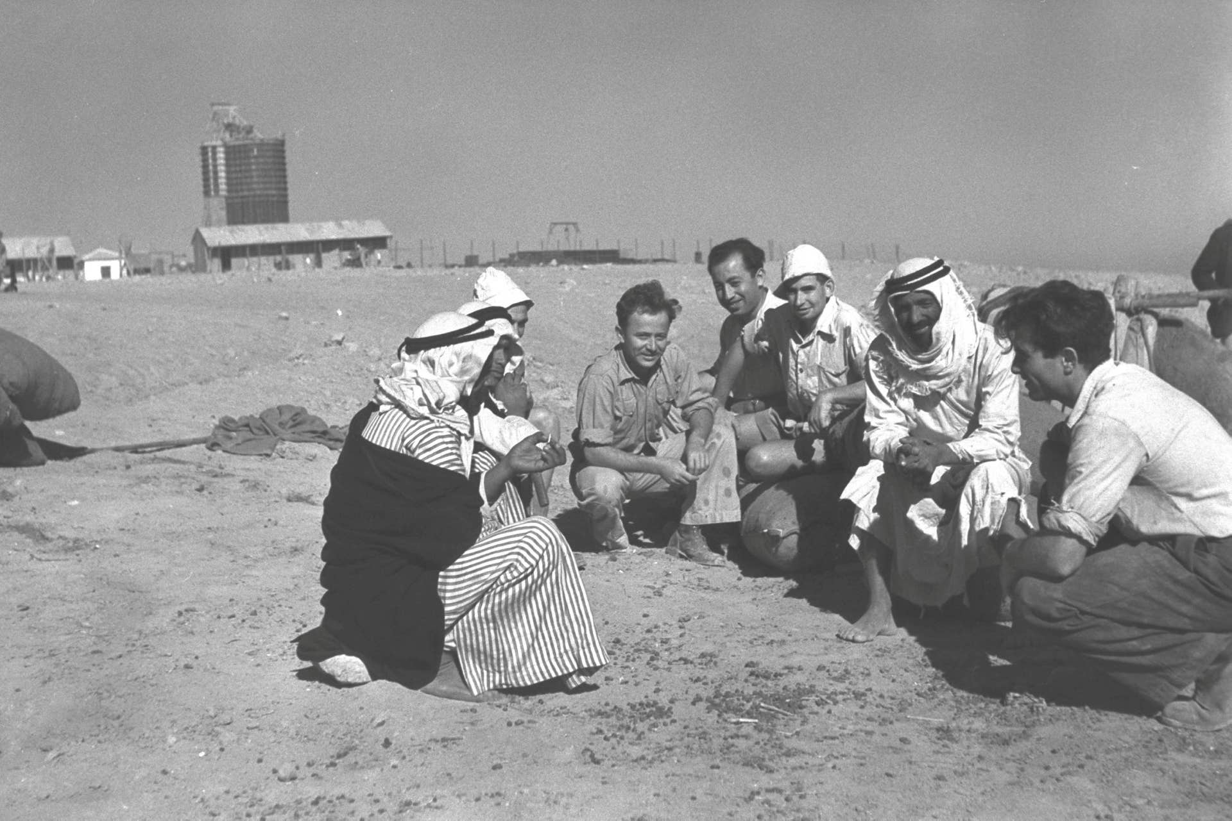

Throughout the hearings, the state and the prosecution did not deny the operation’s existence but argued that against Algazi’s opinion emphasized the civilian considerations of the transfer while playing down the security considerations. The state also raised a claim concerning the operation’s timetable. They argued that operation began before the law was passed, so Dayan could not have known what criteria would be set for seizing land. However, some could argue that Dayan possibly knew about long-term political plans because of his position and standing.
Another issue concerns how long Al-Arakib has existed. The state denied the claim that there was a permanent settlement on Al-Arakib’s lands. The petitioners assert there had been a Bedouin settlement at the site prior to the state’s establishment, based on an opinion provided by Forensic Architecture, a research group at the University of London. Forensic Architecture, headed by Prof. Eyal Weizman, combined digital tools with maps and reconnaissance of Al-Arakib to reach that conclusion. The opinion will take on greater significance if the claimants manage to progress to the second stage of the hearing on proof of ownership.
The state argues the court should reject the claim due to a delay of decades in filing it. But the Bedouin also have a response for that: They were never told the lands were appropriated and the state misled them into thinking the lands had been taken away only temporarily. A letter received in 2000 from the Israel Lands Administration stated that “no appropriation has taken place” on the lands.
One way or the other, all parties are waiting to hear from the court. Meanwhile, Algazi expects to make further findings. “The difficulty is in reconstructing an operation carried out by people who knew it was not really legal, and therefore made sure not to put down certain things in writing,” he tells Haaretz. “In addition, although we are talking about events that took place 70 years ago, only some of the documents have been revealed. We are waiting for the day when we will be able to study all of them.”
+++++++++++++++++++++++++++++++++++++++++++++++++++++++++++++++++++++++++
Netael Bandel is an attorney who writes for Ha’aretz
++++++++++++++++++++++++++++++++++++++++++++++++++++++++++++++++++++++++++
https://israelpalestinenews.org/1951-documents-reveal-israels-intent-to-ethnically-cleanse-bedouin-from-their-lands/

