56 years after the 1967 War, the world still denies the Palestinian experience
As the son of a general who participated in the Nakba in 1948 and the Naksa in 1967, Miko Peled thought he knew Israeli history. But when he finally met Palestinians and heard their stories of Zionist atrocities he was shocked to learn the truth.
BY MIKO PELED JUNE 5, 2023 3
Share on Facebook Share on Twitter
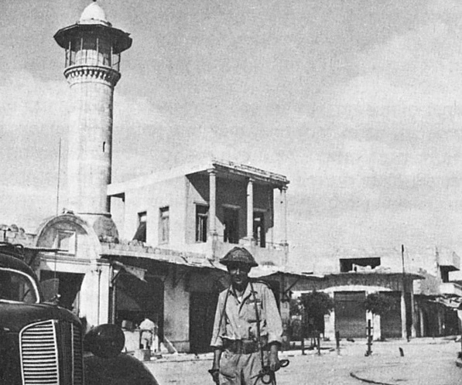DAHMASH MOSQUE IN LYDD AFTER IT IS CAPTURED BY ISRAELI FORCES IN 1948. DAHMASH MOSQUE WAS THE SITE OF A ZIONIST MASSACRE IN 1948. (PHOTO: WIKIMEDIA)
Americans, who give Israel billions of dollars each year, may be interested to know that May and June are monumentally difficult months in the collective memories of Israelis and Palestinians. Personally, each year when May rolls around I am reminded of the first time I spoke to Palestinians about the events of 1948. It was in the year 2001 or 2002, during a meeting of local Jews and Palestinians in San Diego.
I felt that I knew everything there was to know about that period in our joint history because my father, Matti Peled, was a captain in the pre-state Zionist militia, the Haganah. He fought in what we Israelis call the War of Independence. Then, two decades later he was among the generals who planned and executed the 1967 Six-Day War.
The 1948 war, called the Catastrophe, or Nakba in Arabic, was Israel’s War of Independence, and both are commemorated during the month of May. In June Israelis celebrated the 1967 war, considered a massive victory for Israel. Palestinians mourn what they call the “Naksa,” which means setback in Arabic. Today is the Naksa’s 56th anniversary.

“In 1948 the Zionist forces had outnumbered the Palestinian fighters four to one,” George, a Palestinian who I had just met, exclaimed. “We had about ten thousand men, poorly armed and poorly trained. The Zionists had a well-trained and well-armed militia of close to forty thousand.”
“What? No, no, no! We were David in this David and Goliath scenario.” I had to insist. I remember stories of how we, the few, had defeated the well-armed Arabs. I heard stories from my father and his comrades in arms who participated in the battles.
What I hadn’t yet done at that point was read the writings of Dr. Ilan Pappe and other Israeli historians who had published the history of 1948 based on material released from the Israeli national archives. They describe a campaign of planned ethnic cleansing that included massacres aimed at terrorizing the Arab population. These historians, who became known as The New Historians, showed that for the purpose of creating a Jewish majority in Palestine/Eretz Yisrael, the Arab population was forced out.
But I was not aware of that at this point. Another Palestinian, Ibrahim, told another horror story. His father, a young man in 1948, was taken by the Zionist militia which became the Israeli army in May of 1948, to clean up after a massacre at the Dahmash mosque in the city of Lydd. Lydd, where Ben-Gurion Airport sits today, was occupied in July 1948. After more than one hundred Palestinian civilians took refuge in the mosque, a soldier by the name of Yerachmiel Kahanovich was sent to shoot a Piat anti-tank missile into the mosque.
In a video interview that Kahanovich gave in 2012, he described what he did. He put his thumb and index finger together and showed the size of the hole the missile created in the mosque window. He then went to take a look. “I opened the door and the place seemed empty, the people were splattered all over the walls.” After a few days, the Israeli forces sent imprisoned Palestinians to clean up the remains. Ibrahim’s father was one of them.
I did not know, nor could I believe, that we Israelis did such awful things. So when Zionist Jews today refuse to believe Israel has been committing horrendous war crimes and refuse to accept an Amnesty International report that Israel is engaged in the crime of apartheid, I know what they are going through even though I strongly believe it’s time for them to wake up.
After that conversation, I called my brother Yoav in Tel Aviv. I thought that if anyone would be able to help me make sense of what the Palestinians were saying, it was he. “You should read Ilan Pappe and the other New Historians,” he suggested. “It looks like what the Palestinians are telling you is true.”
So now, during May and June, I feel an internal storm brewing. Similar to what I feel as Palestinians continue to tell me their stories. Never accusing, or waving their finger at me, just telling stories that the world does not want to hear.

