IMPORTANT

Attention
These PowerPoint files are very large. For this reason, your PC will likely take a long time to download / open the files.
Have patience and if necessary, try again two or three times. We suggest you download a copy of the PowerPoint files first on your PC and open it there.
Read this file “Important”.
If you do not have Windows Office on your PC buy it or download a PowerPoint Viewer (if possible) or Open Office from the Internet.
The files on this site are a work tool for all militants and colleagues active in community centred political organizations or in propaganda.

Contact : imparalavita@bluemail.ch
Website : www.imparalavita.ch

Suggestions for the use of the files
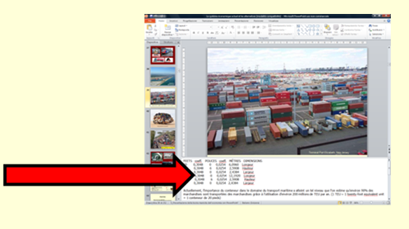
The online files (or CD with the same files) are a work tool.
Offer to schools, political parties, unions, associations, training groups, etc. to organize lessons / lectures / conferences …. On issues such as Palestine and the Economy.

Windows Office format: under the slides comments and useful information.
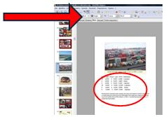
Open Office format: click "NOTE" to view comments
and useful information. The images are not perfect.

PDF format (and PowerPoint Viewer): it is not possible to view comments

Depending on the situation it is important to remember some rules.
In general: it's good to project the presentation with a beamer. Remember that along with a beamer you also need a remote control, a lap top, cables and support (table), an extension lead (with power source), a clear wall space to use as a screen, a bag to put everything in, plus documents to explain the slideshow and distribute to the public. Check / prepare everything some days before and, if possible, make an inspection to the site.
Copies of the CD: it is advisable to create copies with the program "Nero".
In “Documents” there is a folder “Flyers” to print flyers and labels to be inserted in envelopes.
The flyers can be printed and then photocopied in large quantities. The text can also be modified, for example, can be added the name of the organization that distributes the flyer, etc.
There are no copy rights on these files or CD versions, but perhaps only on certain images for which we assume no responsibility. For this reason, we suggest you do not commercialize these files or the CD versions.
Languages available for the website downloads: English, Italian, German, French, Spanish.
On the CD there are the same files that you can find on our website www.imparalavita.ch, but in one language only, order it from imparalavita@bluemail.ch
On request we can send to you free of charge 1, 10, 20 or 50 copies of the CD (more than 1: only for groups or organisations).

Palestine:
-- Talking about Palestine: it is important to give as much information as possible without exceeding the absorption capacity of the audience.
What is historic and modern Palestine?

What has happened and what is happening in Palestine?

What caused this situation?

What lies ahead?

A lecture can be opened with the 4 fundamental questions (suggestion: make a great poster with the 4 questions and
hang it in a highly visible position).

The Poster:

Generally, the files can be used in the following situations:
1 during public lectures (only Palestine)
2 during lectures in colleges (Palestine and economics)
3 during conferences in private circles (Palestine and economics)
4 during festivals, fairs, conferences, etc.

1. Public lectures
-- It is a good idea to put in the lecture room a Palestinian flag and panels with photos or maps of Palestine and keep a small booklet available (the public can prepare themselves while waiting)
-- An introduction is necessary
-- Projection of the short presentation (about 1 hour) or the first 270 slides of the complete presentation with comments (showing the whole presentation is asking too much of the public).
-- Discussion, questions, if possible, with short witness reports.
-- Distribution of a copy of the CD or flyer to those who are particularly interested (teachers, activists, young people and couples at their first contact with politics etc.) and show/suggest some books.

2. Colleges
-- Introduction (students generally already know the theme) with the help of a maxi map
-- Projection (depending on the time available) of the short version of the history (1 hour) or the first 270 slides plus Gaza 2009/2014 (2 hours), with comments
-- Witness reports, discussion, questions - show/suggestion of some books
-- Distribute a copy of the CD or flyers to everybody

3. Small groups
-- Projection of the short presentation (or the complete presentation) and other presentations (Gaza 2009/2014, The wall, Life behind the wall, depending on the time available to the people present) with beamer or laptop, with comments
-- Discussion, questions - show/suggest some books
-- Distribute a copy of the CD or flyers to everybody

4. Conferences, festivals, fairs
-- Ask the organizers for a place or a corner with a table, a plug socket and if possible, a clear wall or a screen to project the short presentation.
-- Set the presentation on "automatic switch" (6 seconds for each slide) and save this set-up. The presentation works automatically. Also show other presentations like “Gaza 2009/2014” and/or "Life behind the wall".
-- Ongoing projection of the presentation on a laptop or beamer placed in a highly visible place. Comments are not needed (since the slides move quite quickly).
-- Distribute documents like a small booklet of pamphlet to everybody and a copy of the CD to those who are particularly interested (teachers, activists, young people and couples at their first contact with politics etc). - show/suggest some books

A frequent question concerns the wall: we must clearly explain that it is not a simple separation barrier, but a huge wall to a prison because it encircles the occupied Palestinian territories completely and also robs the native population of land and water sources far beyond the green line. The Palestinians are effectively locked in an open-air prison.

It is also necessary to underline the persistent fight of the Zionists to erase the Palestinian people in order to finally take ownership of the land and create a land only for Jews.

Economy:

Talking about the economy (see PowerPoint "The current economic system and the alternatives") it is necessary to organize the conference as a dialog with the people present (supported by the projection). You could assign to single individuals a part to play, like. "Owner", "Director", “Car Salesman", “Economics Minister" etc., asking them to take (virtual) decisions and justify them. The exercise consists in showing the Slides only after the students take position on each question. The discussion must be very concrete, i.e. based on examples from everyday life.
The aim is obviously to create political awareness/background: without that, young people fall into the arms of the single thought (bourgeois) or indifference and for us they are lost.

If the presentation is used for thematic study days (atelier), you have to form working groups that perform the exercises as recommended in the notes below the slides. Bring newspapers.

Between the first and the second section it is good to take a little break.
Do not forget to distribute a copy of the flyer or the CD to those who are particularly interested (teachers, activists, young people and couples in their first contact with politics, etc.).

Attention : if at the time of the projection (with a laptop + beamer) the images are not projected on the screen, try to "turn on the secondary screen" with Fn + F5 (try several times), and / or turn the laptop off and on again.

Open the PowerPoint files
If you click on the downloaded file immediately, it will probably not open it. But if you then leave the download folder, go to any other folder and then return to the download folder, the files suddenly open perfectly.

Conference equipment:

Laptop or Tablet / IP with power cord, possibly with the presentation already loaded.
Beamer with a power cord
Beamer remote control
Beamer – Laptop /Tablet / IP connection cable (check the compatibility of sockets)
Laser pointer and flashlight
Extension lead with multiple plug sockets
CD or USB memory stick with the files already loaded
Portable screen
Aventually a small speaker

Useful/essential programs: Nero 7 / Microsoft Office PowerPoint 97-2003 Presentation partially updated 2007 / Microsoft Office Word 97 - 2003 Document

See photo below
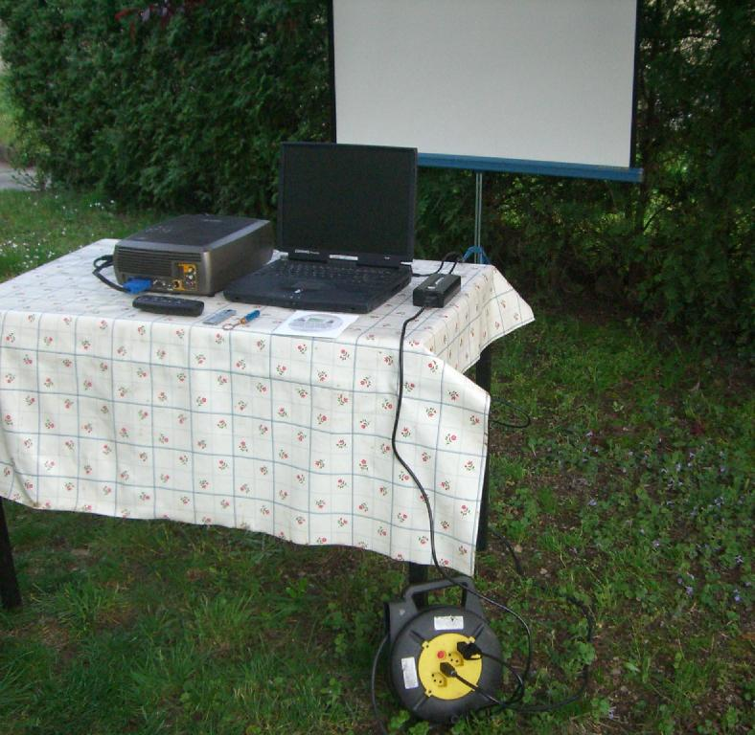

Programs used: Nero 9 / Microsoft Office PowerPoint 97-2003 Presentation partially updated 2007 / Microsoft Office Word 97 - 2003 Document / Microsoft Office Word Rich Text Format

Site advertisement for social media - flyer: (recto)

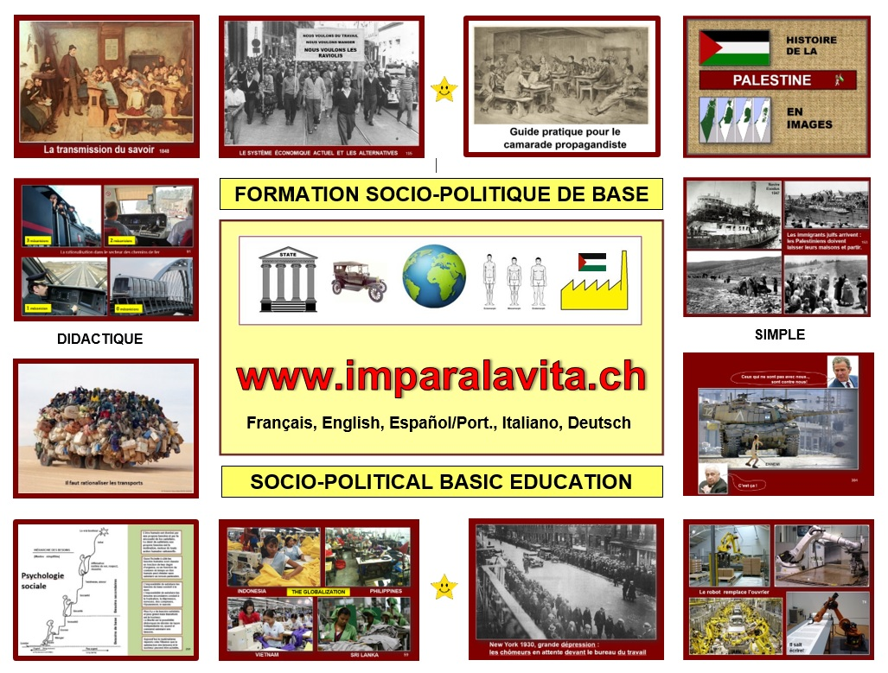
(verso)
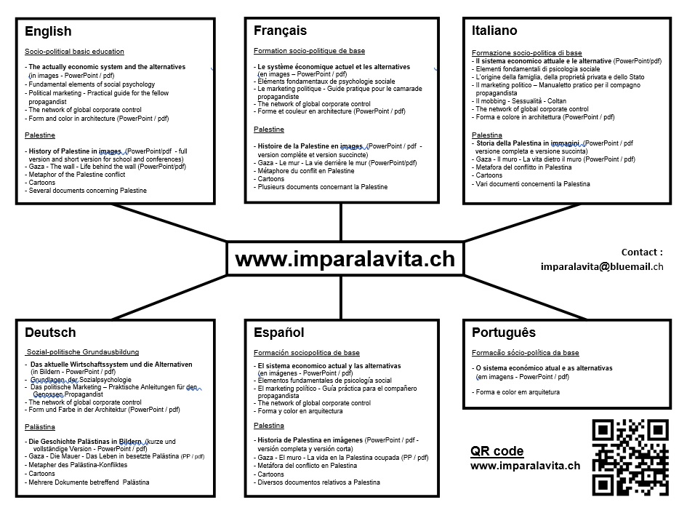

Instructions to download the files.

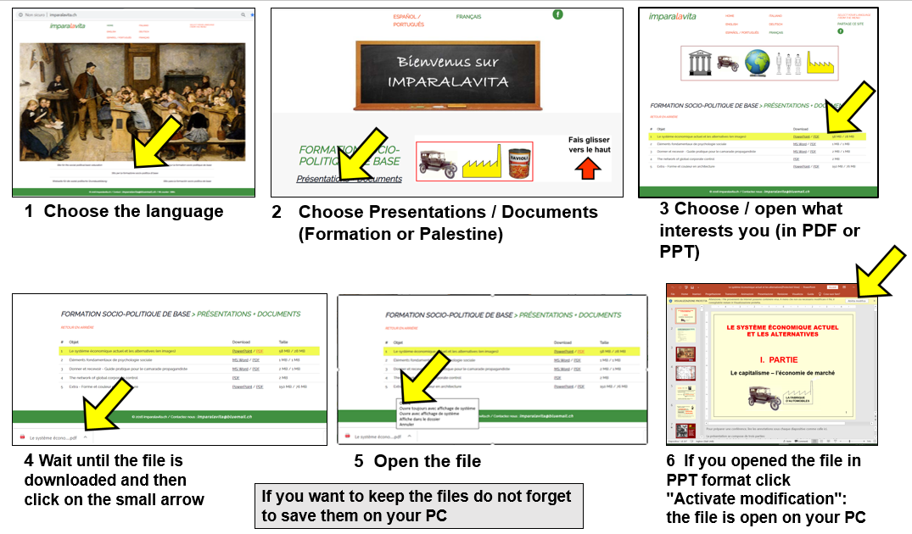

Note that in PDF format annotations and comments are not visible.

