This Is Ours - And This, Too : Israel’s Settlement Policy in the West Bank
Summary of joint report with Kerem Navot, March 2021
The State of Israel is enforcing a regime of Jewish supremacy in the entire area between the Jordan River and the Mediterranean Sea. The fact that the West Bank has not been formally annexed does not stop Israel from treating it as if it were its own territory, particularly when it comes to the massive resources Israel invests in developing settlements and establishing infrastructure to serve their residents. This policy has enabled the establishment of more than 280 settlements and outposts now populated by more than 440,000 Israeli citizens (excluding East Jerusalem). Thanks to this policy, more than two million dunams [1 dunam = 1,000 square meters] of Palestinian land have been stolen, by official and unofficial means; the West Bank is crisscrossed with roads linking the settlements to one another and to Israel’s sovereign territory, west of the Green Line; and the area is dotted with Israeli industrial zones. All these have transformed the geography of the West Bank beyond recognition over the decades.
This report addresses the financial, legal and planning mechanisms that Israeli authorities have been employing for more than half a century to enable the establishment and expansion of settlements and sustain them. It centers on two key aspects:
First, the effort invested by various state authorities to encourage Jews to move to settlements and develop financial ventures in and around them. The state offers a slew of benefits and incentives to settlers and settlements, through both official and unofficial channels – extensively reviewed here. Housing benefits are the most significant, allowing families that lack capital or substantial sources of income to buy homes in settlements. These benefits partly explain the rapid population growth in the large ultra-orthodox settlements in the West Bank – Modi’in Illit and Beitar Illit. In addition, significant tax benefits of up to NIS 200,000 (~USD 60,500) per taxpayer are offered to residents of about 30 settlements, some of which are affluent.
Further benefits and incentives are offered to industrial zones in the West Bank, including discounted land fees and employment subsidies. These drive consistent growth in the number of factories there. Israel also encourages Jews to set up new outposts, which operate as agricultural farms and enable extensive takeover of Palestinian farmland and pastureland. Forty such farms have been established in the past decade, effectively taking over tens of thousands of dunams.
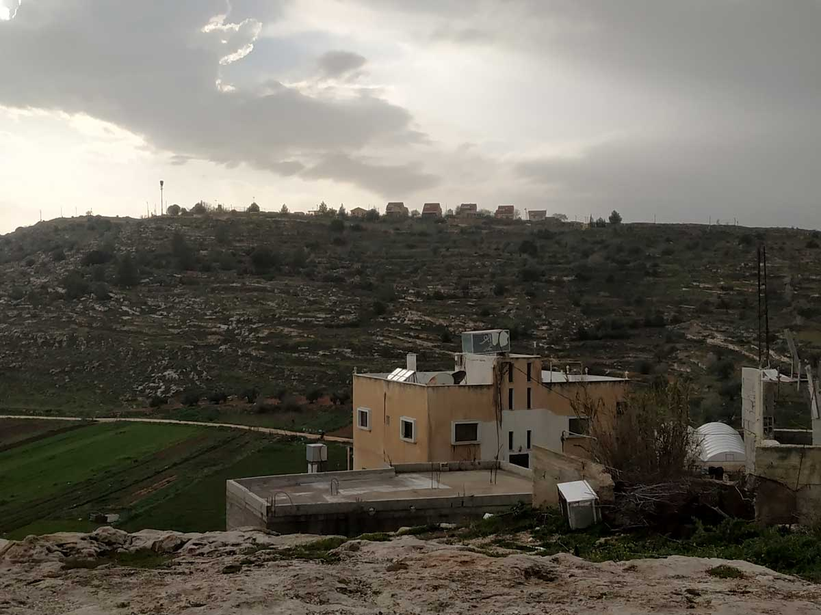LOOKING AT THE SETTLEMENT OF ELI FROM THE VILLAGE OF QARYUT. PHOTO: DROR ETKES, KEREM NAVOT, 23 FEBRUARY 2021.
Second, the report analyzes the spatial impact of two settlement blocs that cut across the West Bank. One bloc, built south of Bethlehem, stretches from the urban settlements of Beitar Illit and Efrat to the west and the settlements belonging to the Gush Etzion Regional Council, which encircle Bethlehem and the villages around it, to the settlement of Nokdim and its environs on edge of the Judean Desert, to the east. The other bloc is located in the center of the West Bank and consists of the settlements of Ariel, Rehelim, Eli, Ma’ale Levona, Shilo and the outposts built around them. This bloc also cuts across the West Bank, reaching the hillsides overlooking the Jordan Valley.
Israel devotes relentless efforts to increasing the population in these two blocs and to extending their geographical footprint. This is pursued by planning new neighborhoods, developing infrastructure, and preparing plans and land reserves for future building and development. These steps have already resulted in an accelerated population growth rate in both blocs over the past decade. The population of Efrat is expected to double, if not triple, in the coming decades. Beitar Illit’s population is expected to grow by 20,000 settlers, and Ariel’s by about 8,000.
The impact of the two blocs extends far beyond their built-up areas (which cover about 20,000 dunams) and the size of their population (a combined total of about 121,000 settlers). Their existence stifles any possibility of sustainable development for Palestinians in the area, and directly impacts the livelihood and future of tens of thousands of Palestinians in dozens of communities.
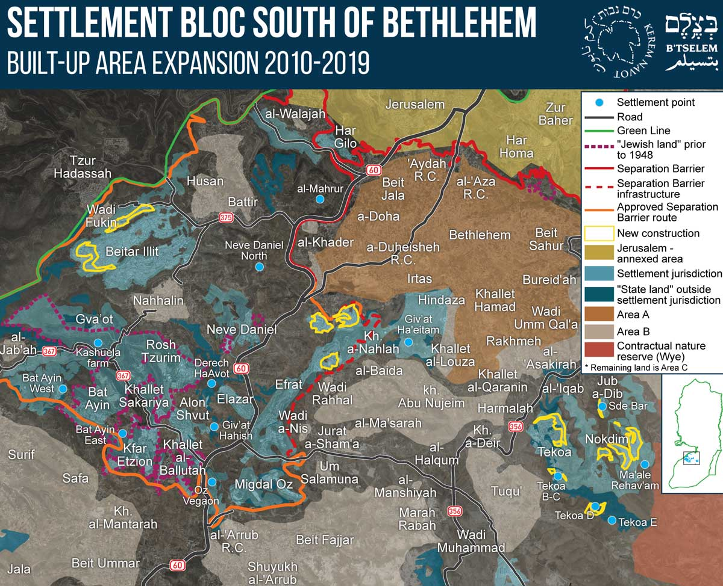
Click here to enlarge map.
- The bloc south of Bethlehem stretches from the Green Line in the west to the edge of the Judean desert in the east, edging the southern municipal boundaries of Jerusalem – including parts of the West Bank Israel annexed weeks after the occupation – and spreading south all the way to al-‘Arrub Refugee Camp. The settlements and outposts in this bloc divide Palestinian space by cutting the Bethlehem area off from the area of Jerusalem in the north and from Hebron and its environs in the south. They also fragment the Bethlehem area itself, turning villages into isolated islands, preventing the city’s future development and controlling Route 60 – the major traffic artery traversing the West Bank from north to south and connecting between Jerusalem, Bethlehem and the southern West Bank.
- The central bloc bisects the West Bank from west to east, disrupting the contiguity of a string of Palestinian communities. The settlements of Eli and Shilo and the outposts around them were built in one of the most populous and fertile areas in the West Bank, which served for generations as a Palestinian rural hub, with residents relying on intensive cultivation of the land for their livelihoods. Settlers in this area have gradually and doggedly dispossessed Palestinians of thousands of dunams of farmland, robbing them of their livelihoods.
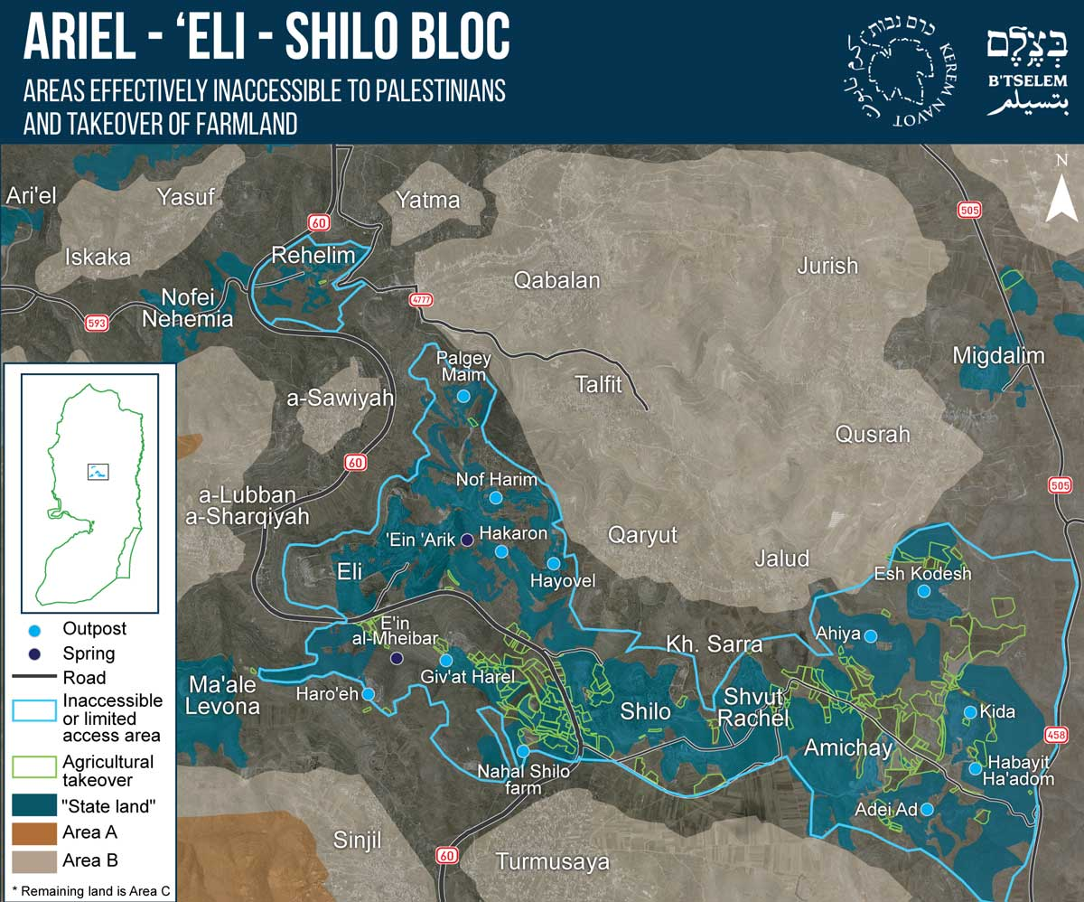
Click here to enlarge map.
Following the establishment of these two settlement blocs, Palestinians have lost access to thousands of dunams of agricultural land, whether directly (in areas declared “state land” or closed by military order) or as a result of the chilling effect of state-backed settler violence, which deters many Palestinians from trying to access their land. Around the settlements of Tekoa and Nokdim, Palestinians have lost access to at least 10,000 dunams. In the vicinity of Shilo, Eli and their satellite outposts, their access is barred to at least 26,500 dunams.
The report should be read in the context of B’Tselem’s recently-published position paper asserting that the Israeli regime, which strives to promote and perpetuate Jewish supremacy in the entire area between the Jordan River and the Mediterranean Sea, is an apartheid regime. The regime’s policy of Judaizing space is not confined to the two settlement blocs discussed in this report. It is implemented throughout the entire area, based on the mindset that land is a resource meant to primarily benefit the Jewish population. Accordingly, land is used to develop and expand existing Jewish settlements and build new ones, while Palestinians are dispossessed and corralled into small, crowded enclaves. This policy has been practiced with respect to land within sovereign Israeli territory since 1948, and applied to Palestinians in the Occupied Territories since 1967.
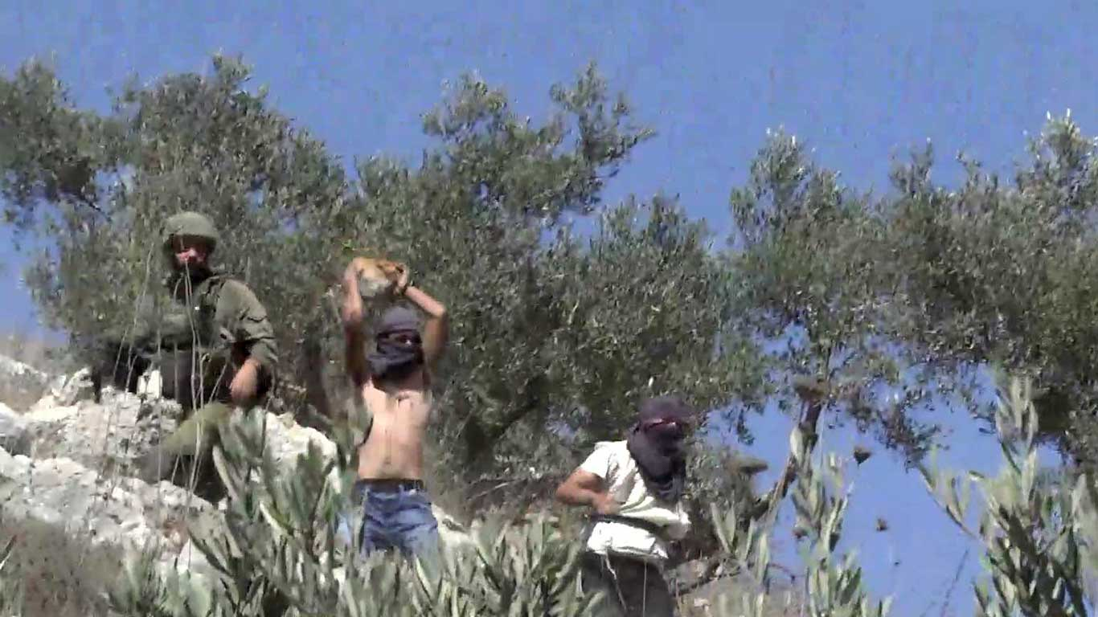SETTLERS ATTACK OLIVE HARVESTERS IN HUWARAH, NABLUS DISTRICT. STILL FROM VIDEO FOOTAGE. VIDEO: MUHAMMAD FAWZI, 7 OCTOBER 2020.
While de-jure annexation of the West Bank may have been shelved, this is immaterial in practice – as the report demonstrates yet again. Construction and infrastructure work has recently been carried out in the West Bank on a scale not seen in decades. This large-scale development is designed to facilitate another significant spike in the number of settlers living in the West Bank, which settlement leaders predict will reach one million in the near future.
This massive investment further entrenches Israel’s hold on the West Bank, clearly demonstrating the regime’s long-term plans. These include cementing the position of millions of Palestinians as subjects denied rights and protection, who are deprived of any ability to influence their own future and forced to live in disconnected, dwindling, economically suppressed enclaves. They are forced to look on as they are dispossessed of more and more land, while communities and infrastructure are built for Jewish citizens. Two decades into the 21st century, Israel appears more determined than ever to continue upholding and perpetuating an apartheid regime throughout the area under its control, well into the coming decades.

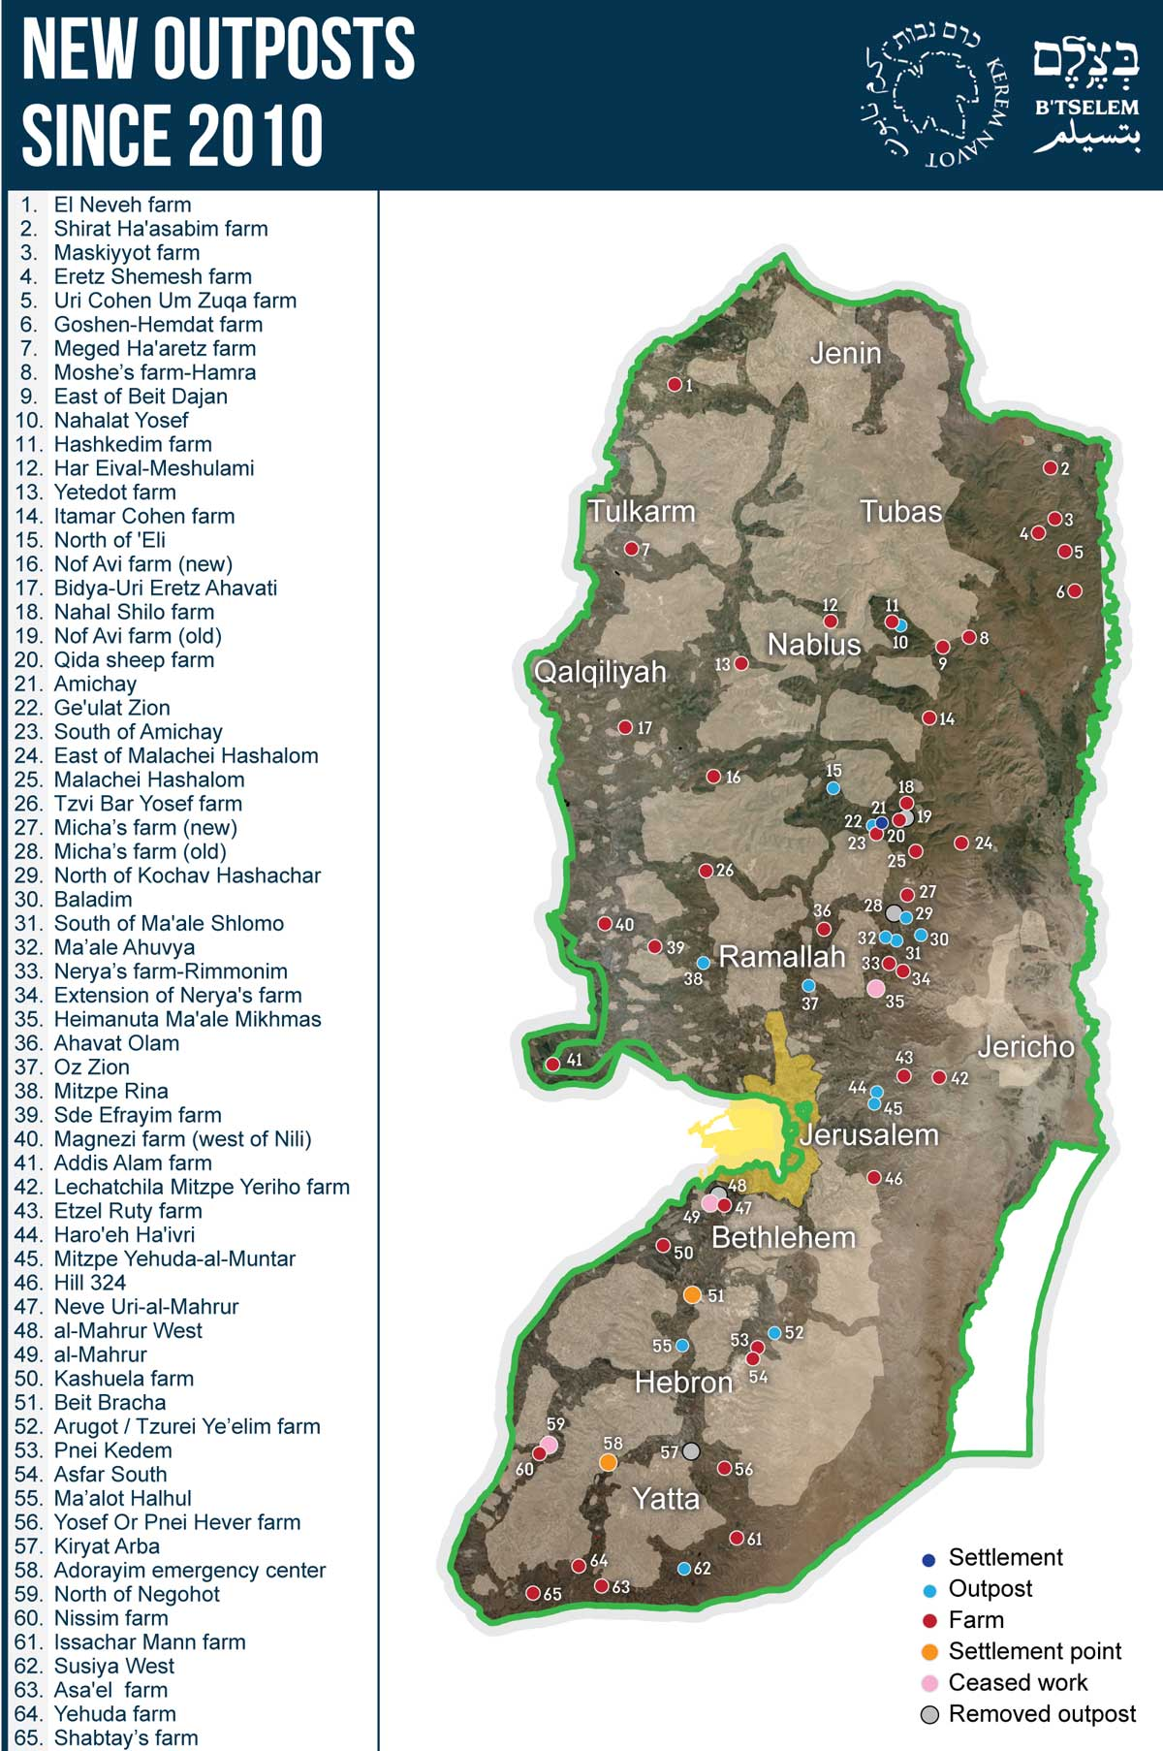
Click here to enlarge map.

https://www.btselem.org/publications/202103_this_is_ours_and_this_too

