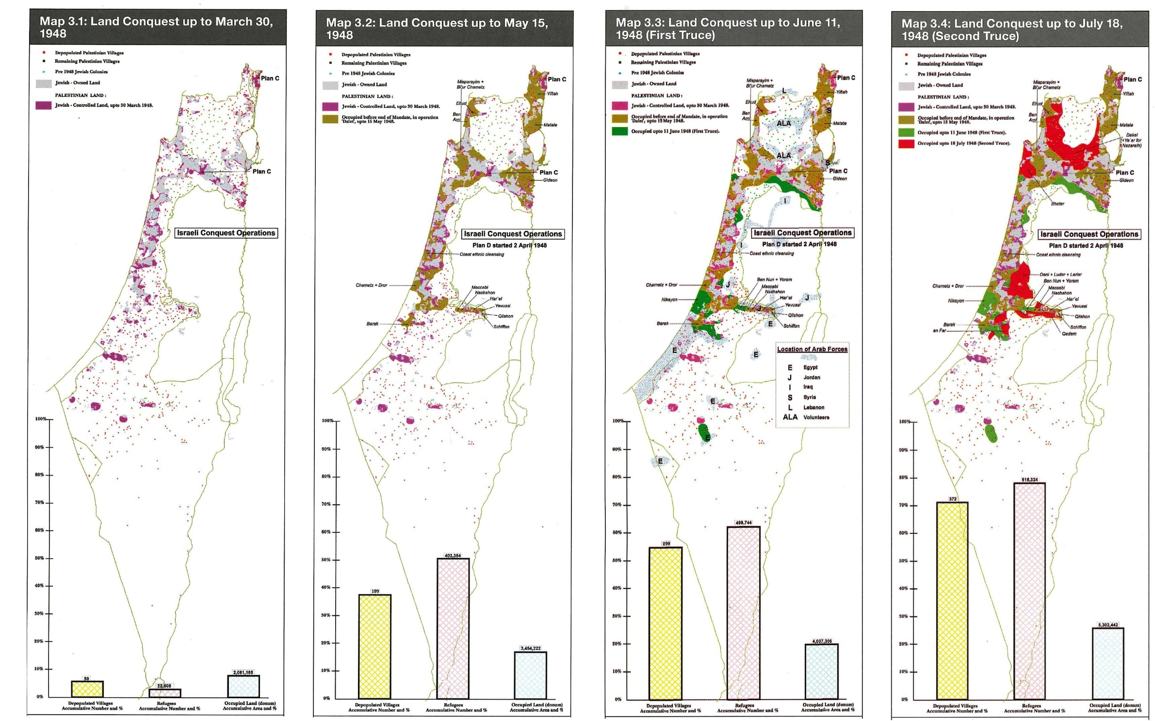

**Palestine - Nakba : maps 1**

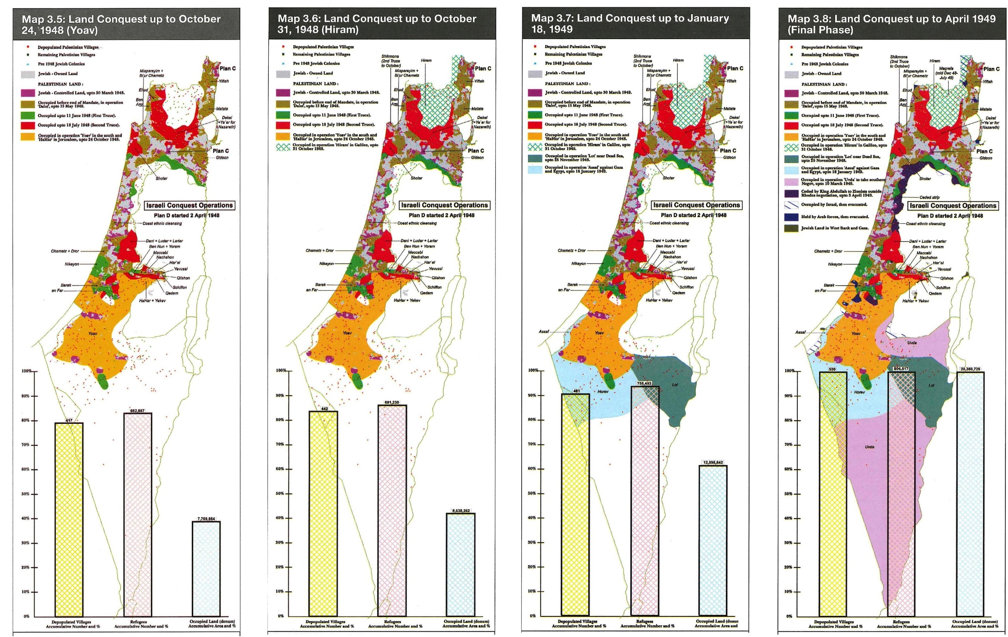

**Palestine - Nakba : maps 2**

**Ten years of research into the 1947-49 war**

**The expulsion of the Palestinians re-examined**

Fifty years ago the UN decided to partition Palestine into two states, one Arab, one Jewish. The ensuing Arab-Israeli war ended with Israel expanding its share of the land by a third, while what remained to the Arabs was occupied by Egypt and Jordan. Several thousand Palestinians fled their homes, becoming the refugees at the heart of the conflict. Israel has always denied that they were expelled, either forcibly or as a matter of policy. Israel’s “new historians” have been re-examining that denial and have put an end to a number of myths.

by Dominique Vidal

Only a few acknowledged that the father’s story of return, redemption and liberation was also a story of conquest, displacement, oppression and death.

Yaron Ezrachi, Rubber Bullets

Between the partition plan for Palestine adopted by the General Assembly of the United Nations on 29 November 1947 and the 1949 ceasefire that ended the Arab-Israeli war, begun by the invasion of 15 May 1948, several hundred thousand Palestinians abandoned their homes in territory that ended up occupied by Israel (1).

Palestinian and Arab historians have always maintained that this was an expulsion. The vast majority of the refugees (estimated at between 700,000 and 900,000) were, they say, forced to leave, first, as a result of clashes between Israelis and Palestinians, and then by the Arab-Israeli war, in which a political-military strategy of expulsion had been marked by several massacres. This position was stated as far back as 1961, by Walid Khalidi, in his essay “Plan Dalet: Master Plan for the Conquest of Palestine” (2) and has recently been restated by Elias Sanbar in “Palestine 1948. L’Expulsion” (3).

Mainstream Israeli historians, on the other hand, have always claimed that the refugees (numbering, in their estimation, 500,000 at most) mostly left voluntarily, responding to calls from their leaders assuring them of a prompt return after victory. They deny that the Jewish Agency (and subsequently the Israeli government) had planned the exodus. Furthermore, they maintain that the few (and regrettable) massacres that occurred - particularly the Deir Yassin massacre of 9 April 1948 - were the work of extremist soldiers associated with Menachem Begin’s Irgun and Yitzhak Shamir’s Lehi.

However, by the 1950s this version was already beginning to be contested by leading Israeli figures associated with the Communist Party and with elements of the Zionist left (notably Mapam). Later, in the mid-1980s, they were joined in their critique by a number of historians who described themselves as revisionist historians: Simha Flapan, Tom Segev, Avi Schlaim, Ilan Pappe and Benny Morris. It was Morris’s book, “The Birth of the Palestinian Refugee Problem”, that first prompted public concern (4) . Leaving aside differences of subject, methodology and viewpoint, what unites these historians is that they are bent on unpicking Israel’s national myths (5). They have focused particularly on the myths of the first Arab-Israeli war, contributing (albeit partially, as we shall see), to establishing the truth about the Palestinian exodus. And in the process they have incurred the wrath of Israel’s orthodox historians (6).

This research activity was originally stimulated by two separate sets of events. First, the opening of Israeli archives, both state and private, covering the period in question. Here it is worth noting that the historians appear to have ignored almost entirely both the archives of the Arab countries (not that these are notable for their accessibility) and oral history potential among Palestinians themselves, where considerable work has been done by other historians. As the Palestinian historian, Nur Masalha, rightly says: “History and historiography ought not necessarily be written, exclusively or mainly, by the victors (7)".

Second, this delving into Israel’s archives would perhaps not have borne such fruit if the following ten years had not been marked by the Israeli invasion of Lebanon in 1982 and by the outbreak of the intifada in 1987. Both these events accentuated the split between the nationalist camp and the peace movement in Israel itself. As it turned out, the “new historians” were uncovering the origins of the Palestinian problem at precisely the moment that the whole question of Palestine was returning to centre stage.

In a recent article in the “Revue d’études palestiniennes” (8), Ilan Pappe, one of the pioneers of this “new historiography”, has stressed the importance of the dialogue that was unfolding in that period between Israelis and Palestinians. It developed, he says, “basically among academics. Surprising as it may seem, it was thanks to this dialogue that most Israeli researchers who were working on their country’s history and who had no links to the radical political organisations, became aware of the version of history held by their Palestinian counterparts. They became aware of the fundamental contradiction between Zionist national ambitions and their enactment at the expense of the local population in Palestine.”

To this we might add that the manipulation of history for political ends is not an exclusively Israeli domain: most often it goes hand in hand with nationalism.

What lessons have the revisionist historians drawn from their diligent working-through of the archives? As regards the broad picture of the balance of power between Jews and Arabs in both 1947 and 1948, their results contradict the generally-held picture of a weak and poorly armed Jewish community in Palestine threatened with extermination by a highly armed and united Arab world - David versus Goliath. Quite the contrary. The revisionists concur in pointing to the many advantages enjoyed by the nascent Jewish state over its enemies: the decomposition of Palestinian society; the divisions in the Arab world and the inferiority of their armed forces (in terms of numbers, training and weaponry, and hence impact); the strategic advantage enjoyed by Israel as a result of its agreement with King Abdullah of Transjordan (in exchange for the West Bank, he undertook not to attack the territory allocated to Israel by the UN); British support for this compromise, together with the joint support of the United States and the Soviet Union; the sympathy of world public opinion and so forth.

This all helps to explain the devastating effectiveness of the Jewish offensives of spring 1948. It also sheds new light on the context in which the mass departure of Palestinians took place. The exodus was divided into two broadly equal waves: one before and one after the decisive turning-point of the declaration of the State of Israel on 14 May 1948 and the intervention of the armies of the neighbouring Arab states on the following day. One can agree that the flight of thousands of well-to-do Palestinians during the first few weeks following the adoption of the UN partition plan - particularly from Haifa and Jaffa - was essentially voluntary. The question is what was the truth of the departures that happened subsequently?

In the opening pages of “The Birth of the Palestinian Refugee Problem”, Benny Morris offers the outlines of an overall answer: using a map that shows the 369 Arab towns and villages in Israel (within its 1949 borders), he lists, area by area, the reasons for the departure of the local population (9). In 45 cases he admits that he does not know. The inhabitants of the other 228 localities left under attack by Jewish troops, and in 41 cases they were expelled by military force. In 90 other localities, the Palestinians were in a state of panic following the fall of a neighbouring town or village, or for fear of an enemy attack, or because of rumours circulated by the Jewish army - particularly after the 9 April 1948 massacre of 250 inhabitants of Deir Yassin, where the news of the killings swept the country like wildfire.

By contrast, he found only six cases of departures at the instigation of local Arab authorities. “There is no evidence to show that the Arab states and the AHC wanted a mass exodus or issued blanket orders or appeals to the Palestinians to flee their homes (though in certain areas the inhabitants of specific villages were ordered by Arab commanders or the AHC to leave, mainly for strategic reasons).” ("The Birth of the Palestinian Refugee Problem", p. 129). On the contrary, anyone who fled was actually threatened with “severe punishment”. As for the broadcasts by Arab radio stations allegedly calling on people to flee, a detailed listening to recordings of their programmes of that period shows that the claims were invented for pure propaganda.

Military operations marked by atrocities

In “1948 and After” Benny Morris examines the first phase of the exodus and produces a detailed analysis of a source that he considers basically reliable: a report prepared by the intelligence services of the Israeli army, dated 30 June 1948 and entitled “The emigration of Palestinian Arabs in the period 1/12/1947-1/6/1948”. This document sets at 391,000 the number of Palestinians who had already left the territory that was by then in the hands of Israel, and evaluates the various factors that had prompted their decisions to leave. “At least 55% of the total of the exodus was caused by our (Haganah/IDF) operations.” To this figure, the report’s compilers add the operations of the Irgun and Lehi, which “directly (caused) some 15%... of the emigration”. A further 2% was attributed to explicit expulsion orders issued by Israeli troops, and 1% to their psychological warfare. This leads to a figure of 73% for departures caused directly by the Israelis. In addition, the report attributes 22% of the departures to “fears” and “a crisis of confidence” affecting the Palestinian population. As for Arab calls for flight, these were reckoned to be significant in only 5% of cases...

In short, as Morris puts it, this report “undermines the traditional official Israeli ’explanation’ of a mass flight ordered or ’invited’ by the Arab leadership”. Neither, as he points out, “does [the report] uphold the traditional Arab explanation of the exodus - that the Jews, with premeditation and in a centralised fashion, had systematically waged a campaign aimed at the wholesale expulsion of the native Palestinian population.” However, he says that “the circumstances of the second half of the exodus” - which he estimates as having involved between 300,000 and 400,000 people - “are a different story.”

One example of this second phase was the expulsion of Arabs living in Lydda (present-day Lod) and Ramleh. On 12 July 1948, within the framework of Operation Dani, a skirmish with Jordanian armoured forces served as a pretext for a violent backlash, with 250 killed, some of whom were unarmed prisoners. This was followed by a forced evacuation characterised by summary executions and looting and involving upwards of 70,000 Palestinian civilians - almost 10% of the total exodus of 1947- 49. Similar scenarios were enacted, as Morris shows, in central Galilee, Upper Galilee and the northern Negev, as well as in the post-war expulsion of the Palestinians of Al Majdal (Ashkelon). Most of these operations (with the exception of the latter) were marked by atrocities - a fact which led Aharon Zisling, the minister of agriculture, to tell the Israeli cabinet on 17 November 1948: “I couldn’t sleep all night. I felt that things that were going on were hurting my soul, the soul of my family and all of us here (...) Now Jews too have behaved like Nazis and my entire being has been shaken (10).”

The Israeli government of the time pursued a policy of non- compromise, in order to prevent the return of the refugees “at any price” (as Ben Gurion himself put it), despite the fact that the UN General Assembly had been calling for this since 11 December 1948. Their villages were either destroyed or occupied by Jewish immigrants, and their lands were shared out between the surrounding kibbutzim. The law on “abandoned properties” - which was designed to make possible the seizure of any land belonging to persons who were “absent” - “legalised” this project of general confiscation as of December 1948. Almost 400 Arab villages were thus either wiped off the map or Judaised, as were most of the Arab quarters in mixed towns. According to a report drawn up in 1952, Israel had thus succeeded in expropriating 73,000 rooms in abandoned houses, 7,800 shops, workshops and warehouses, 5 million Palestinian pounds in bank accounts, and - most important of all - 300,000 hectares of land (11).

In “1948 and After” (chapter 4), Benny Morris deals at greater length with the role played by Yosef Weitz, who was at the time director of the Jewish National Fund’s Lands Department. This man of noted Zionist convictions confided to his diary on 20 December 1940: “It must be clear that there is no room in the country for both people (...) the only solution is a Land of Israel, at least a western Land of Israel without Arabs. There is no room here for compromise. (...) There is no way but to transfer the Arabs from here to the neighbouring countries(...) Not one village must be left, not one (bedouin) tribe.”

Seven years later, Weitz found himself in a position to put this radical programme into effect. Already, in January 1948, he was orchestrating the expulsion of Palestinians from various parts of the country. In April he proposed - and obtained - the creation of “a body which would direct the Yishuv’s war with the aim of evicting as many Arabs as possible”. This body was unofficial at first, but was formalised at the end of August 1948 into the “Transfer Committee” which supervised the destruction of abandoned Arab villages and/or their repopulation with recent Jewish immigrants, in order to make any return of the refugees impossible. Its role was extended, in July, to take in the creation of Jewish settlements in the border areas.

Israel’s battle to bar the return of Palestinian exiles was also pursued on the diplomatic front. Here, as Henry Laurens noted in a review of the revisionist historians (12), “the opening- up, and the use, of the archives made it possible to revise a number of previously-held positions. Contrary to the widely held view, the Arab leaders were prepared for compromise.” As soon as the war ended, the Arab leadership was trying, within the context of the Lausanne Conference, to arrive at a general settlement based on Arab acceptance of the UN partition plan (Ilan Pappe gives a detailed account of their efforts (13)), in exchange for Israeli acceptance of a right of return for the refugees. Despite international pressure - with the United States to the fore - this enterprise was to founder on the intransigence of the Israeli authorities, particularly once the Jewish state had been admitted to the United Nations.

Despite this extraordinary accumulation of evidence, Benny Morris concludes in his first book that “the Palestinian refugee problem was born of war, not by design, Jewish or Arab.” ("The Birth...", p. 286) His second book offers a more considered approach, in which he recognises that the Palestinian exodus was “a cumulative process, there were interlocking causes, and there was a main precipitator, a coup de grace, in the form of Haganah, Irgun and IDF assault in each locality”. ("1948...", p. 32). This shift of position does not, however, prevent him from continuing to resist any notion of a Jewish expulsion plan, and to exonerate David Ben Gurion, president of the Jewish Agency and subsequently prime minister and defence minister of the newly-created Israeli state.

As Norman G. Finkelstein has highlighted, in a textual study that is as brilliant as it is polemical (14), this twin denial by Benny Morris seems at first sight to contradict what Morris says himself. After all, he himself tells us that “the essence of the [Dalet] plan was the clearing of hostile and potentially hostile forces out of the interior of the prospective territory of the Jewish State, establishing territorial continuity between the major concentrations of Jewish population and securing the Jewish State’s future borders before, and in anticipation of, the Arab invasion.” ("The Birth...", p. 62) And he also recognises that Plan D, while it did not give carte blanche for an expulsion of civilians, was nevertheless “a strategic-ideological anchor and basis for expulsions by front, district, brigade and battalion commanders” for whom it provided “post facto a formal persuasive covering note to explain their actions” (p. 63). Benny Morris contrives to make two seemingly contradictory statements within two pages of each other, namely that “Plan D was not a political blueprint for the expulsion of Palestine’s Arabs” and that “from the beginning of April, there are clear traces of an expulsion policy on both national and local levels”. ("The Birth...", pp. 62 and 64)

The same is true as regards the responsibility or otherwise of David Ben Gurion. Morris makes clear that the prime minister was the originator of the Dalet Plan. In July 1948 we find Ben Gurion again, giving the order for the operations in Lydda and Ramleh: “Expel them!” he told Yigal Allon and Yitzhak Rabin - a section censored out of Rabin’s memoirs, but published thirty years later in the “New York Times” (15). This order, Morris tells us, had not been debated within the Israeli government. In fact, some days previously the Mapam, partner of the ruling Mapai, had obtained from the prime minister an instruction explicitly forbidding the military to carry out expulsion measures... Ben Gurion later attacked the hypocrisy of this Marxist Zionist party for condemning “activities” in which its own militants, Palmah troops and kibbutzniks alike, had also taken part.

In Nazareth, General Chaim Laskov decided to take the official instruction literally. One story has Ben Gurion arriving there, discovering the local population still in situ, and declaring angrily “What are they doing here?” (16) Also in July, but this time in Haifa, we have Ben Gurion as the man behind the scenes in the operation for the “de-localisation” of the 3,500 Arabs still remaining in the town, followed by the partial destruction of the former Arab quarter.

In short, as Morris himself points out, power at that period of Israel’s history resided with Ben Gurion and with him alone. All issues, whether military or civilian, were decided with him, often without the slightest consultation with the government, let alone with the parties that comprised it. In such a situation, the absence from the archives of any formal parliamentary or governmental decision to expel the Palestinians proves nothing. As Morris himself admits, “Ben Gurion always refrained from issuing clear or written expulsion orders; he preferred that his generals ’understand’ what he wanted done. He wished to avoid going down in history as the ’great expeller’” ("The Birth...", pp. 292-3).

The fact that the founder of the State of Israel took advantage of the impressive extent of his powers and worked towards the maximum enlargement of the territory allocated to the Jewish state by the United Nations, and towards reducing its Arab population to a minimum, is a matter of historical fact. Morris devoted an important article (17) to Ben Gurion’s long-term support for the transfer project. As he writes in his preface to “1948 and After...”, “Already from 1937 we find Ben Gurion (and most of the other Zionist leaders) supporting a ’transfer’ solution to the ’Arab problem’ (...) Come 1948, and the confusions and deplacement of war, and we see Ben Gurion quickly grasp the opportunity for ’Judaising’ the emergent Jewish State” ("1948 and After..., p. 33).

Prior to this, he tells us that “the tendency of military commanders to ’nudge’ Palestinians’ flight increased as the war went on. Jewish atrocities - far more widespread than the old histories have let on (there were massacres of Arabs at Ad Dawayima, Eilaboun, Jish, Safsaf, Majd al Kurum, Hule (in Lebanon), Saliha and Sasa, besides Deir Yassin and Lydda and other places) - also contributed significantly to the exodus” ("1948...", p. 22).

The “original sin”

Ilan Pappe, a professor at the University of Haifa, devotes two chapters of his book “The Making of the Arab- Israeli Conflict, 1947-1951” to these issues. Eschewing the caution of Morris’s position, he concludes that “Plan D can be regarded in many respects as a master plan for expulsion. The plan was not conceived out of the blue - expulsion was considered as one of many means for retaliation against Arab attacks on Jewish convoys and settlements; nevertheless, it was also regarded as one of the best means of ensuring the domination of the Jews in the areas captured by the Israeli army” ("The Making...", p. 98).

Furthermore, the actual text of Plan D leaves very little doubt as to the intentions of Ben Gurion and his friends. It spoke of “operations against enemy population centres located inside or near our defensive system in order to prevent them from being used as bases by an active armed force. These operations can be carried out in the following manner: either by destroying villages (by setting fire to them, by blowing them up, and by planting mines in their debris), and especially of those population centres which are difficult to control continuously; or by mounting combing and control operations according to the following guidelines: encirclement of the village, conducting a search inside it. In case of resistance, the armed force must be wiped out and the population expelled outside the borders of the state” ("The Making...", p. 92).

For their achievements, and despite their limitations, we should applaud the courage of Israel’s new historians. This is not just any old page of history on which they have worked to shed light. What they have opened to public view is the “original sin” of the state of Israel. Is it acceptable for the survivors of Hitler’s genocide to have the right to live in a state of their own, and for this right to exclude the right of the sons and daughters of Palestine to live similarly at peace in their own country? Fifty years after the event, the time is long overdue to bring an end to this logic that has generated so much war, and to find a way for the two peoples to coexist. At the same time, we should not draw a veil over the historical origins of the tragedy

Translated by Ed Emery

**More from** [**Dominique Vidal**](http://mondediplo.com/_Dominique-Vidal_)

([1](http://mondediplo.com/1997/12/palestine#nh1)) This article was the basis of a contribution to a colloquium on “The History of Contemporary Palestine” held at the Institut du Monde Arabe on 13 June 1997. It is being developed into a book to be published by Editions de l’Atelier in spring 1998.

([2](http://mondediplo.com/1997/12/palestine#nh2)) In *Middle East Forum*, November 1961, reprinted with a new commentary in the *Journal of Palestine Studies*, Beirut, vol. XVIII, no. 69, 1988.

([3](http://mondediplo.com/1997/12/palestine#nh3)) Elias Sanbar, in “Palestine 1948. L’Expulsion”, “Revue d’études palestiniennes, Paris, 1984.

([4](http://mondediplo.com/1997/12/palestine#nh4)) Their most important publications are: Simha Flapan, “The Birth of Israel, Myth and Realities”, Pantheon Books, New York, 1987; Tom Segev, “1949. The First Israelis”, Free Press MacMillan, New York and London, 1986; Avi Schlaim, “Collusion across the Jordan: King Abdullah, the Zionist Movement and the Partition of Palestine”, Clarendon Press, Oxford, 1988; Ilan Pappe, “Britain and the Arab-Israeli Conflict, 1948-1951”, MacMillan, New York, 1988 and “The Making of the Arab-Israeli Conflict, 1947- 1951”, I.B. Tauris, London, 1992; and Benny Morris, “The Birth of the Palestinian Refugee Problem, 1947-1949”, Cambridge University Press, Cambridge, 1987, and “1948 and After. Israel and the Palestinians”, Clarendon Press, Oxford, 1990.

([5](http://mondediplo.com/1997/12/palestine#nh5)) The probing is obviously not limited to the first Arab- Israeli war. It also involves the attitude of the Zionist leadership to genocide (see in particular Tom Segev’s “The Seventh Million”, published in France by Liana Levi, Paris, 1992), and the nature of Jewish settlement during the period of the British mandate. Similarly, Benny Morris has pursued his exploration of the archives in order to shed light on Israeli expansionism during the 1950s (ÒIsrael’s Border Wars: Arab Infiltration, Israeli Retaliation and the Countdown to the Suez War”, Clarendon Press, Oxford, 1993) It also extends into other disciplines apart from historiography, particularly to sociology, and especially concerning the situation of Oriental Jews in Israeli society, from the early days to the present.

([6](http://mondediplo.com/1997/12/palestine#nh6)) See particularly Shabtai Teveth, “The Palestinian Refugee Problem and its Origins”, *Middle Eastern Studies*, vol. 26, no. 2, 1990, and Ephraim Karsh, “Fabricating Israeli History: The “New Historians””, Frank Cass, London, 1997.

([7](http://mondediplo.com/1997/12/palestine#nh7)) Nur Masalha,”’1948 and After’ revisited", *Journal of Palestine Studies*, no. 96, vol. XXIV, no. 4, summer 1995.

([8](http://mondediplo.com/1997/12/palestine#nh8)) Ilan Pappe, “La critique post-sioniste en Israel”, *La Revue d’études palestiniennes*, no. 12, summer 1997.

([9](http://mondediplo.com/1997/12/palestine#nh9)) “The Birth...” op. cit., pp. 14-18. A careful comparison of the text of the book with the tables showing village by village the principal reasons for the exodus reveals a clear - and surprising - underestimation in the tables of the extent of actual expulsions.

([10](http://mondediplo.com/1997/12/palestine#nh10)) Tom Segev, op. cit., p. 26.

([11](http://mondediplo.com/1997/12/palestine#nh11)) Quoted by Simha Flapan, op. cit., p. 107.

([12](http://mondediplo.com/1997/12/palestine#nh12)) Henry Laurens, “Travaux récents sur l’histoire du premier conflit israélo-arabe”, *Maghreb-Machrek*, Paris, no. 132, April-June 1991.

([13](http://mondediplo.com/1997/12/palestine#nh13)) “The Making...”, op. cit., chapters 8-10. See also Jean-Yves Ollier, “1949: la conférence de Lausanne ou les limites du refus arabe”, *Revue d’études palestiniennes*, no. 35, spring 1990.

([14](http://mondediplo.com/1997/12/palestine#nh14)) Norman G. Finkelstein, “Image and Reality of the Israel-Palestine Conflict”, Verso, London and New York, 1995, chapter 3.

([15](http://mondediplo.com/1997/12/palestine#nh15)) *New York Times*, 23 October 1979.

([16](http://mondediplo.com/1997/12/palestine#nh16)) This story was told by Ben Gurion’s biographer, Michel Bar-Zohar, and was reproduced in the Israeli daily *Hadashot*, Tel Aviv, 19 October 1986.

([17](http://mondediplo.com/1997/12/palestine#nh17)) Benny Morris, “Remarques sur l’historiographie sioniste de l’idée d’un transfert de populations en Palestine dans les années 1937-1944”, in “Les nouveaux enjeux de l’historiographie israélienne”, ed. Florence Heymann, Information paper, Centre de recherche français de Jérusalem, no. 12, December 1995. On the contradictions of Mapam’s position, see the first chapter of “1948 and After”

***800,000 Refugees created over a period of twenty months***

**1947**

**29 November:** The General Assembly of the United Nations adopts, with the required two thirds majority, a plan to partition Palestine into a Jewish state, an Arab state, and an international zone involving Jerusalem and the Holy Places.

**1948**

**January:** Volunteer units organised as the Arab Liberation Army of Assistance (ALA) entered Palestine.

**End of March:** First deliveries of Czechoslovak arms to the Jewish forces. The Dalet Plan is put into operation.

**9 April:** Deir Yassin massacre.

**18 April:** The Haganah take Tiberias; four days later they take Haifa.

**10 May:** Safed is taken, followed by Jaffa two days later.

**14 May:** End of the British Mandate. Declaration of the State of Israel. De facto recognition of the new state by the United States. The armies of five Arab countries enter Palestine.

**17 May:** De jure recognition of Israel by the Soviet Union. The Haganah take St Jean d’Acre. The following day Egyptian troops take Beersheba.

**28 May:** The Jewish quarter of Jerusalem capitulates.

**11 June-8 July:** First truce.

**9-17 July:** Israel takes Lydda, Ramleh and Nazareth.

**18 July-15 October:** Second truce.

**17 September:** Assassination of the Swedish UN mediator Count Folke Bernadotte by an extremist Zionist commando unit.

**15 October:** The Israeli army breaks the truce, and begins an offensive in the Negev.

**11 December:** The General Assembly of the United Nations calls for the refugees to have the right of return.

**22 December:** Renewed fighting between Egypt and Israel. Israel completes its conquest of the Negev. Israel withdraws from northern Sinai on 7 January 1949, but only after a threat of direct British intervention.

**1949**

**24 February:** Armistice between Israel and Egypt.

**10 March:** Israeli troops take Um Rashrash (Eilat).

**23 March:** Armistice between Israel and Lebanon.

**3 April:** Armistice between Israel and Transjordan.

**11 May:** Israel is admitted to the United Nations.

**12 May:** Israel and the Arab states sign the protocols of the Lausanne Conference.

**20 July:** Armistice between Israel and Syria.

**8 December:** Establishment of the United Nations organisation for Palestinian refugees (UNRWA).

Sources

http://mondediplo.com/1997/12/palestine#nb9

https://qcpal.files.wordpress.com/2016/06/nakba-maps1-4-low.jpg

https://qcpal.files.wordpress.com/2016/06/nakba-maps-5-8-low.jpg